Hoofprint
Shickley Public School

…preparing students
for success…

February 2015

Monthly Newsletter

Notes from Mr. Jorgenson
Groundhog Day. A day in which Punxsutawney Phil, the world’s most famous groundhog, will emerge to see how much winter we have left. That means that the changing of the seasons is just around the corner and spring will soon be upon us. At times, this can be a difficult time for parents and teachers because there are not a lot of breaks from school. However, at school it begins our most important time as we begin to take the assessments that are mandated by the Nebraska Department of Education. Everyone needs to dig down deep and find the drive to do well on these assessments. Shickley traditionally has performed very well on these tests, and I do not expect this year to be any different. We have great teachers and students here, and I know that they are always striving to do their best.

Remember that parent/teacher conferences are just around the corner. Due to the large number of Kindergartners, we have made Mrs. Schultz available the entire day on February 5th to help ease the scheduling process. All of the other conferences will take place from 2:00-7:00. Please be respectful of other teachers and parents as we want to keep conferences with teachers at a maximum of 15 minutes to ensure that everyone has ample time to ask questions and receive feedback on the status of their children.

By the time you have received this newsletter, the board will have met for a retreat to discuss the goals of the school district. Those goals will be written out and placed on the website to be viewed by everyone. It is important for the school board to have a definite direction for the district, and it will be my job to help guide the district to reach those goals. The board then will evaluate me based on the progress we make toward reaching those goals.

One last reminder: Men, do not forget your ladies on February 14!

Bryce Jorgenson
Superintendent
bjorgenson@longhornpower.org

Spanish News

¿Tienes hambre? ¿Tienes sed?
Are you hungry? Are you thirsty?
According to the Spanish students, the answer is definitely, “¡Sí!”

As we progress into the second semester, all of the Spanish classes have been concentrating on food, by using various food props and activities. After learning some verbs and basic general vocabulary for the first part of the year, the fifth and sixth graders have been learning the Spanish names for several different types of food and a few adjectives to describe them. They are also communicating in Spanish with each other about their opinions regarding different types of food. Although the 7th graders are presently learning verbs, they will soon begin the food unit, as well. (The 7th graders only take Spanish this nine weeks during this year.) The juniors in Spanish I take it a step further and learn more words describing places that sell food and the people involved. After learning the last of the eight different verb tenses, the seniors taking Spanish 2 are using the food vocabulary not only to review all of the verb tenses, but also to communicate to each other about food. The emphasis for them is upon situations that they may encounter concerning food in the future outside of high school.

With the emphasis upon food, everyone is finding that it is necessary to eat a breakfast, or else there are bound to be some hunger pains in class!

Today you are You,
That is truer than true.
There is no one alive
Who is Youer than You.
-Dr. Seuss

Nebraska State FFA Choir

Our FFA chapter had numerous members audition for the Nebraska State FFA Choir. The students pictured below have been selected to perform with the Nebraska State FFA Choir at State convention in Lincoln in April: Chris Lichti, Carley Elznic, Ben Elznic, and Anthony Beavers.

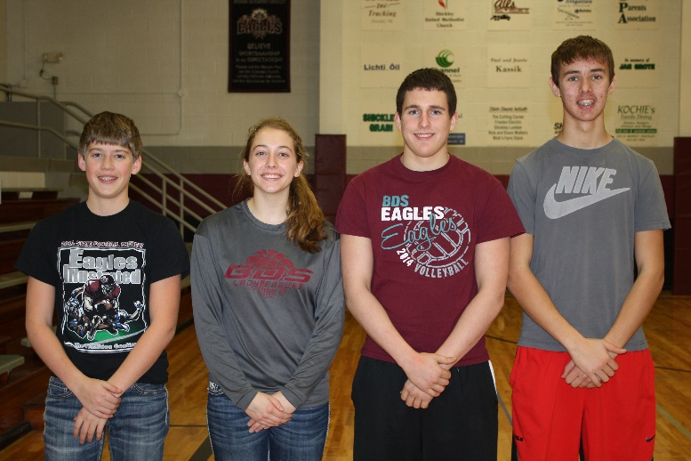

Fourth Grade News

With the beginning of 2015, each fourth grade student came up with some New Year’s Resolutions to try and achieve.

The 4th grade class has been busy learning long division since returning from Christmas vacation. This has been a challenge for some, but they are excited being able to work with larger numbers. We are still working hard at solving story problems with many different strategies such as guess and check, work backwards, making a table, or acting it out.

On January 15th we celebrated National Hat Day by wearing our favorite hat to school. We discussed some of the basic rules that go along with wearing a hat such as tipping your hat when you meet a lady or an elder person. This is a sign of respect and greeting. Hats are also required to be removed during funeral processions, when the National Anthem is played, or when the national flag is passed. In our discussion we talked about how hats were originally worn to protect people from the glaring sunlight, the sudden rainfall, or the cold snow. As time has passed we think hats are now worn more as a fashion statement by both men and women.

As January comes to an end we will be focusing on the state writing test for 4th grade students.

Pictured below are Brianna Jorgenson, Coy Fiegel, Gracie Swartzendruber, Hannah Miller, Ashley Schlegel, and teacher Mr. Sorge.

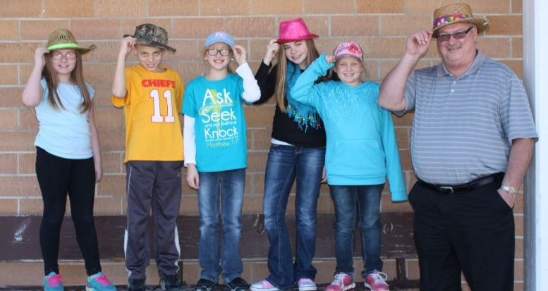

Honor Roll for Second Quarter

All A’s

Seniors
Nathan Hendrickson, Megan Swartzendruber, Kristin Troyer

Juniors
Catherine Mick, Tristen Mosier

Sophomores
Courtney Kamler

Freshmen
Megan Grote, Nicole Swartzendruber

8th Grade
Jackson Grote, Jadyn Kleinschmidt

7th Grade
Regan Alfs, Kaylee Noel, Alyssa Nolt

A Average

Seniors
Rio Mohrmann, Logan Rosenquist, Blake Stengel

Juniors
Madison Yantzie

Sophomores
Christian Lichti

Freshmen
Anthony Beavers, Carley Elznic, Lexi Kadel, Kellen Reinsch, Holden Stengel, Jacob Swartzendruber

8th Grade
Caleb Hendrickson, Isaac Kamler, Josiah Kamler

7th Grade
Raegan Fiala, Brooke Jorgenson, Joshua Swartzendruber

Honor Roll for First Semester

All A’s

Seniors
Nathan Hendrickson, Megan Swartzendruber, Kristin Troyer

Juniors
Catherine Mick, Tristen Mosier

Sophomores
Courtney Kamler

Freshmen
Megan Grote, Nicole Swartzendruber

8th Grade
Jackson Grote, Jadyn Kleinschmidt

7th Grade
Regan Alfs, Kaylee Noel, Alyssa Nolt

A Average

Seniors
Rio Mohrmann, Logan Rosenquist, Bret Smith, Blake Stengel

Juniors
Madison Yantzie

Sophomores
Christian Lichti

Freshmen
Anthony Beavers, Carley Elznic, Lexi Kadel, Thomas Mick, Kellen Reinsch, Jacob Swartzendruber

8th Grade
Caleb Hendrickson, Isaac Kamler, Josiah Kamler

7th Grade
Raegan Fiala, Brooke Jorgenson, Justin Stengel, Joshua Swartzendruber

Speech Season Gets Underway

The Longhorn speech team is “suiting up” for the 2015 season. They have been busy researching, writing, revising, and editing speeches; planning, designing, and making visual aids; and selecting, cutting, and preparing scripts.

You are invited to come and support our speakers anytime. Speech meets start early in the morning and run throughout the day. Specific information about times becomes available as dates draw near; for details, please feel free to contact Mrs. Ippensen. If you’ve never been to a speech meet, you are really missing out! This is a great time to see our students practicing professional behaviors, developing public speaking skills, and having fun. Team members and regular attendees would be happy to help you navigate your first meet! If you have been a speech-goer in the past, we thank you for your support and welcome you back this season.

2015 Team Members

Seniors
Nathan Hendrickson
Rio Mohrmann
Bret Smith
Megan Swartzendruber
Kristin Troyer
Junior
Catherine Mick
Sophomore
Chris Lichti
Freshman
Nicole Swartzendruber

Tentative Speech Schedule

Saturday, February 7 Aurora
Saturday, February 21 Sutton
Wednesday, February 25 CRC @ Meridian
Saturday, February 28 Centura (Cairo)
Saturday, March 7 Doniphan-Trumbull
Monday, March 16 Longhorn Speech Night, 7:00 P.M.
Tuesday, March 17 District D2-1 @ Meridian
Friday, March 27 State Contest @ Kearney

Be sure to mark your calendar for Longhorn Speech Night, Monday, March 16th at 7:00 P.M., so you can see our competitors’ final performances prior to the district contest.
Doane Honor Festival Choir

Kristin Troyer auditioned and was selected to the Doane Honor Festival Choir. The festival was held on January 11th-12th. The choir was represented by junior and senior students from all across the state. The choir rehearsed for 10 hours over their 2 days together. They then performed a concert on January 12th.

Pictured are Kristin Troyer and Mr. Harris.

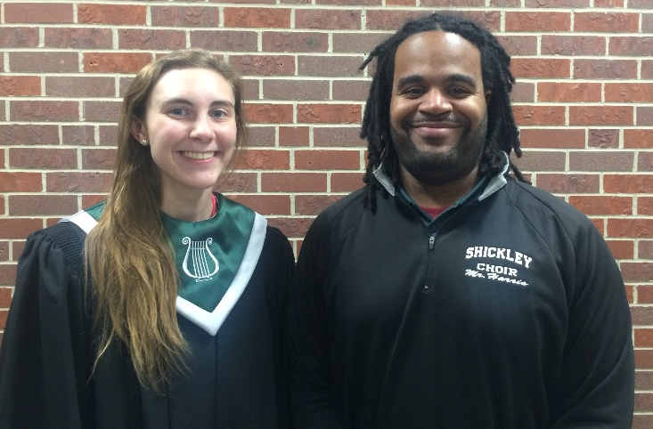

Grandparent Reading

The Shickley first graders are very fortunate to have four wonderful “grandparents” who are willing to listen to students read during their independent reading time. The children look forward to that special time each day when they can just enjoy reading with an adult. These “grandparents” make a significant impact on the students’ reading fluency. The grandparents are Larry Carlson, Frances Heinrichs, Iris Wagers, and Marge Dowdy. If you are interested in becoming a “grandparent” please call Mrs. Nelson at school.

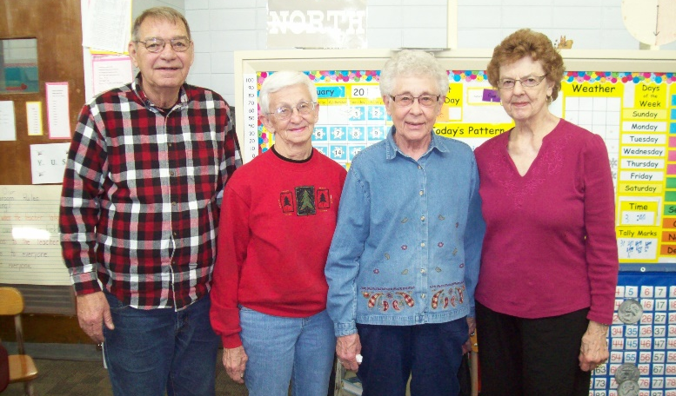
Have You Encouraged Your Kids Lately?

What probably comes to mind for most of us is encouraging our kids on the court or field. Maybe it is congratulating them for an excellent score, playing a musical instrument, or performing in a play production. Or, perhaps it’s a sincere hug for a great report card at the end of the semester.

I’m thinking of a different kind of encouragement. It’s encouragement for our kids to consider making Shickley their future home-to live, have a family and make a career here. Lifestyles have sped up and we now live in a global economy. People have become very mobile in getting what they need and want. Technology has made almost anything you need or want just a “click” away no matter where you call home.

Shickley may not possess the fancy brick and mortar of larger metro areas. On the other hand, the metro areas don’t possess the fresh, open air that a small community offers. I think back over the years of people my age who couldn’t wait to move out of the small town, only to wish they had the opportunity to get out of the city later in their lives. We have all heard of people spending a significant amount of time just to commute to work in the larger cities. Given that amount of time around here, one could travel to almost any given place of work without the traffic! Most business can be conducted from home offices or from the business district of your small town.

As a school board we strive to work with our administrators and teachers to offer as many curriculum and educational opportunities to our students as we can. This will always be an on-going goal. Academic standards continue to be pushed to higher levels for our students. We have a great staff and learning environment to allow for students to reach out and explore what interests them. We want to encourage students’ opportunities and career paths available in and around Shickley. But we realize, ultimately, it is the student’s decision. We will support their dreams and goals wherever they take them. The school mission statement holds true, we are “preparing students for success.”

Students, where do you see Shickley in the future? Does it have something to offer you? Last year the Shickley Community Foundation began presenting the graduating seniors their own mailboxes with a Shickley address on the side. It is just a reminder to encourage our kids that they are always welcome to come home and make their lives here.

Dan Miller
School Board Member

Chemistry News

In Chemistry we are talking about the different types of chemical reactions. Each student had to present and do a demonstration on a type of chemical reaction. Tristen had an entertaining combustion reaction demonstration, where she used methane gas and heat to create a fire in her hands! Catherine pictured here is showing a decomposition reaction with yeast and hydrogen peroxide. Hydrogen peroxide (H₂O₂) decomposes into water and oxygen gas, 2H₂O₂2H₂O + O₂(g). This reaction makes foamy bubbles run out of the bottle.

FFA Competes in LSEs

On January 21st members of the Shickley FFA traveled to the Leadership Center in Aurora to compete in the District VI Leadership Skills Events. More than 20 members competed in public speaking and parliamentary procedure events. The following members were selected as alternates for state: Catherine Mick in Natural Resources (blue ribbon); Rio Mohrmann in Cooperative speaking (blue); Chris Lichti in Jr. Public (blue ribbon); Jr. Par Law team of Chris Lichti, Courtney Kamler, Kale Kleinschmidt, Carley Swartzendruber, John Alfs, Kellen Reinsch, and Wyatt Deepe (blue ribbon). Kellen Reinsch placed fourth receiving a purple in Creed Speaking, and Samantha Plock was fourth in Job Interview with a blue ribbon. The parliamentary team of Anthony Beavers, Thomas Mick, Jacob Swartzendruber, Lexi Kadel, Carley Elznic, Holden Stengel, and Nicole Swartzendruber received a red ribbon. Nicole Swartzendruber was the 1st blue in Creed speaking. In Extemporaneous speaking Blake Stengel and Tristen Mosier both were awarded blue ribbons. Megan Swartzendruber received a blue in Senior Public speaking. In Job Interview Nathan Hendrickson received a red ribbon. Members competed well and enjoyed learning from this experience.

Pictured below are the FFA members who competed on January 21st.

Letter from Mr Ippensen, Principal

“The will to win, the desire to succeed, the urge to reach your full potential... these are the keys that will unlock the door to personal excellence.”
- Confucius

I have spoken at length regarding the measures Shickley Public School is taking to prepare our students for success, but one of the most critical components is, as the quote above states, the desire to succeed. This is an unmeasurable trait, but when you see it, you recognize it. It lies in the desire to solve all of the problems correctly, in the push to understand an entire concept, and in the effort given to get all of the work done well and on time. One of the most important things people can learn is the reward gained from hard work, and we are proud of our students who give this effort. These students don’t always get A’s. But they do work hard to understand and apply the ideas and concepts, to further develop their skills and knowledge. This effort toward continual improvement may very well be a better indicator of preparedness for success than grades on the report cards. (Having said that, one of the rewards to working hard is often better grades on report cards.)

As always, if you have any questions or comments regarding the work we are doing at Shickley Public School, or if you would like to share in the process of preparing our students for success, please don’t hesitate to stop in and talk, or give us a call.

Derek Ippensen
PK-12 Principal
Shickley Public School

