Hoofprint
Shickley Public School

…preparing students
for success…

January 2015

Monthly Newsletter

Notes from Mr. Jorgenson
As you receive this Hoofprint, we are in the middle of our Christmas break. It is a great time to “recharge the batteries” and to be able to visit some family and friends. Hopefully, all of you were able to partake in some rest and relaxation as well as visiting people that you may not see every day. Nevertheless, when break is over usually kids are not ready to come back, but the parents are ready for school to begin. On January 6th, we will begin the second half of the school year. We will be ready to finish the school year strong.
Here are a few reminders:
- January 5th there is no school due to our teachers attending a professional development day in Dorchester.
- The “official” end of first semester is January 9th. Report cards will be sent home the following week.
- Parent/Teacher conferences will be February 5th from 2:00-7:00. School will be dismissed at 1:00 that day. There will not be school on February 6th, but teachers will have an in-service from 8:00-12:00 that day.
- Be watching for the Annual Report to Patrons. It will be mailed out to everyone. It gives a summary of our district for 2013-2014.
I hope you have a wonderful break. From all of us here at Shickley Public School, we hope you had a very merry Christmas and enjoy the wonderful New Year.
Bryce Jorgenson
Superintendent
bjorgenson@longhornpower.org

Junior High Quiz Bowl Team

The Jr. High Quiz Bowl team traveled to Dorchester and had a great day of academic competition. They went 2-2 on the day. They lost to the eventual champions. The students had a fun day of learning and challenging themselves.
Pictured below are: Mr. Shipley, Regan Alfs, Kaylee Noel, Isaac Kamler, Alyssa Nolt, Josiah Kamler, Jadyn Kleinschmidt, Caleb Hendrickson, and Jackson Grote.
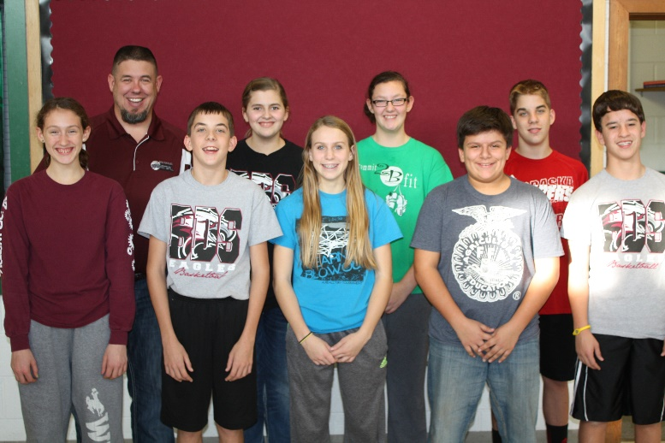

“Then the Grinch thought of something he hadn’t before! What if Christmas, he thought, doesn’t come from a store? What if Christmas…perhaps…means a little bit more?
--Dr. Seuss, How the Grinch Stole Christmas

It was a “Wonderful” One-Act Season

Shickley’s one-act play production this year was “Sherlock Holmes in Wonderland” by Geff Moyer, a comedy-mystery mash-up in which crucial items went missing in Wonderland. In the play, the infamous crime solving duo of Sherlock Holmes and Dr. Watson find themselves kidnapped and delivered to the Queen of Hearts who demands that they discover what has been stolen and by whom. The famous detectives question the White Rabbit, the Mad Hatter, and the Cheshire Cat while attempting to solve the crime in time, or lose their heads on the chopping block!

The season started off with a home performance during Longhorn Arts Night on Monday, November 10th. Then, they competed with other CRC plays at Cross County on Wednesday, November 19th, where Logan Rosenquist and Tristen Mosier were recognized for their outstanding performances. At the Lincoln High School Festival on Tuesday, November 25th, Mosier was named to the Outstanding Festival Cast. Shickley hosted the district D2-1 contest on Tuesday, December 2nd and came away as District Champions! Logan Rosenquist, Kristin Troyer, Rio Mohrmann, Chris Lichti, Bret Smith, and Tristen Mosier were recognized for their outstanding district performances.

Having won the district competition, Shickley moved on to the state contest hosted at the Johnny Carson Theater in Norfolk on Wednesday, December 10, 2014. This year marked Shickley’s first state qualification in play production, and they received superior ratings from each of the three judges. They finished the season in 5th place for Class D2. Tristen Mosier’s performance was recognized with a nomination for Best Actress. (See related article.)

Cast members were Rio Mohrmann (White Rabbit), Logan Rosenquist (Axeman), Bret Smith (Dr. Watson), Kristin Troyer (Queen of Hearts), Catherine Mick (Card Guard/Alice), Tristen Mosier (Mad Hatter), Courtney Kamler (Cheshire Cat), Chris Lichti (Sherlock Holmes), Lexi Kadel (Card Guard), Megan Grote (Card Guard), and Nicole Swartzendruber (Card Guard). Carley Swartzendruber assisted with directing and served as the sound technician. Nathan Hendrickson led the stage crew which included: John Alfs; Wyatt Deepe; Jackson Grote, the turntable operator; Caleb Hendrickson on spot light; Isaac Kamler; and Josiah Kamler. Madison Yantzie assisted with make up and ran the light board.

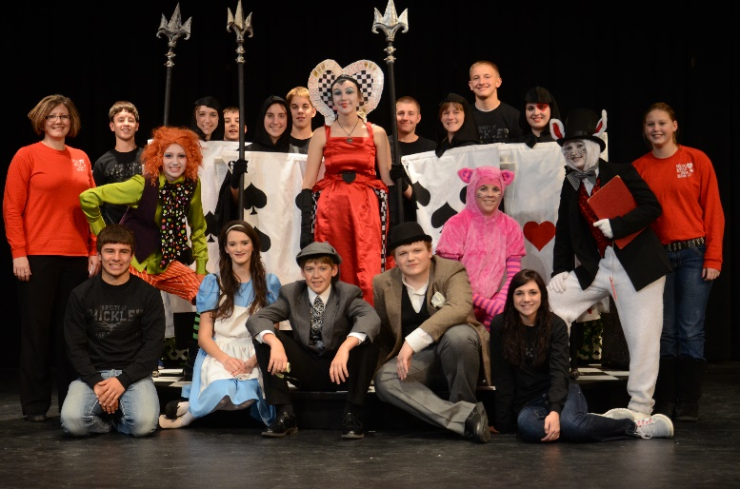

Tristen Mosier Receives Best Actress Nomination at State

Tristen Mosier who played the part of the Mad Hatter was nominated for Best Actress. To be nominated, the performer must be unanimously selected by the judges. Mosier was one of only three Class D2 female performers to receive this distinction. Director Jennifer Ippensen was not surprised by Mosier’s success, but proud of her and happy that her efforts were recognized at the state level. “Tristen is one of those young performers you hope to have the opportunity to work with. She is not only talented, but also dedicated. Her willingness to take direction and consistently work to improve her performance really paid off,” Ippensen said.

The Mad Hatter Goes Hatless. Tristen Mosier portrays The Mad Hatter, whose famous hat has gone missing in Shickley's production of "Sherlock Holmes in Wonderland" by Geff Moyer. Her performance blended the typical zeal and zest of the Mad Hatter's character with an unexpected and over-the-top depression over having become "boring." Mosier was nominated for Best Actress in Class D2 at the state contest held in Norfolk on Wednesday, December 10th.

Getting Creative in 3rd Grade

Students in Miss Johnson’s third grade class have had multiple opportunities to be creative and explore the world of writing. During writing class, students have been working on three paragraph formal writing essays. Formal writing is when students gather ideas by brainstorming, create a rough draft, revise, and add the final touches to a final draft. The students worked on a story, “If I Were Stuck in a Snow Globe….” They had to explain how they got in the globe, what they did when they were in the globe, and how they got out of the globe. They then posed for pictures and created a snow globe of their own with a picture of them inside. The students’ writings have become very creative.
Pictured are some of their writings along with their snow globes.
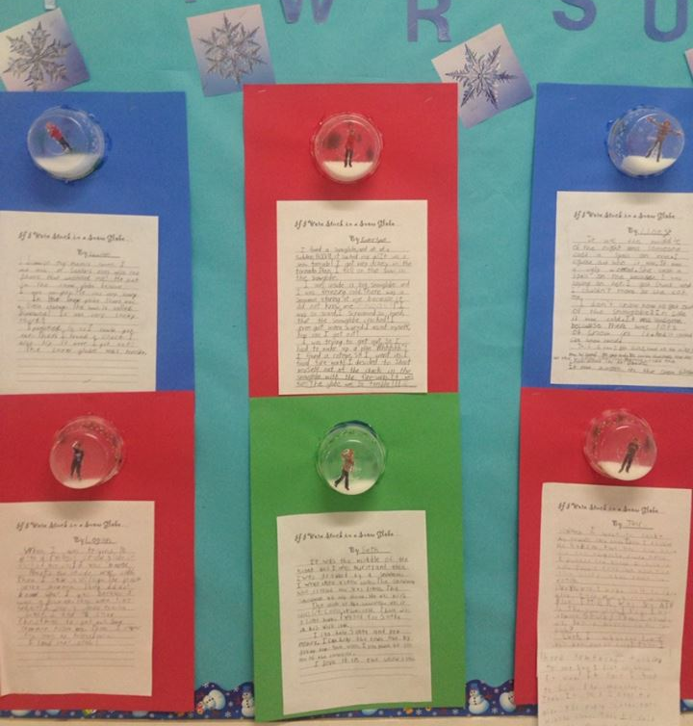

Daycare News

November 11, 2014 was Daycare’s one year anniversary of being open! We started out with three children enrolled and our numbers have grown to eight. We hope to continue to grow each year. We are very grateful for such a great facility to work in. The School Board, administration, and staff of Shickley Public Schools have been a terrific support.

The daycare had a visit from the Easter Bunny in April, 2014 and participated in the homecoming parade in September, 2014. They take daily walks over to the school to mingle with the administration, teachers, and students. The daycare kids love their interaction with the school. They look forward to their visit each day.

Please feel free to stop by the daycare anytime. We love to have visitors. Thanks again to everyone for all the support and love you show these children. We try hard to make their days at daycare like being at home. We are their “Home away from Home.”

Pictured are Ellie Heinrichs, Addie Anderson, Xander Wiseman, Liv Wilson, Emmett Mussman, Madison Mussman, and Coy Elting.

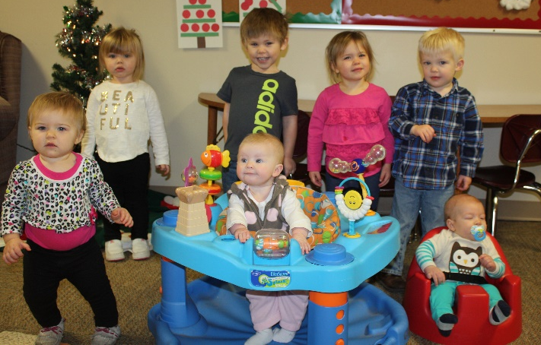

UNL Math Day

UNL Math Day, hosted by the UNL Department of Mathematics, celebrated its 25th anniversary on Thursday, November 20, 2014, on the University of Nebraska-Lincoln City Campus. Over 1,500 students took the PROBE (Problems Requiring Original Brilliant Effort) I exam. All students participated in the multiple choice exam.

The second event of the day was the Math Bowl, a double-elimination tournament pitting three-member teams against each other. The team competitions were divided into six classes according to school enrollment for grades 9 through 12. Trophies were given to the top three teams in each division.

Shickley High School students participating were Nathan Hendrickson, Bret Smith, Blake Stengel, Kristin Troyer, Catherine Mick, and Tristen Mosier.

Wrapping up 2014 in Style

The FFA has had a busy December with the completion of fruit sales and delivering all the product. To celebrate the end of the year the FFA hosted a Christmas Party. Members took part in a mystery meal where they selected their food at random which meant some interesting combinations. One group received frosting, crackers, and hot dogs. Another group received chicken noodle soup but no utensils to eat it with. It was a great time. Senior Nathan Hendrickson said, “tonight was a chance for all of us to hang out together and have some fun before break starts.” Members are excited for the start of second semester and to be busy after break.

Information Technology

The Information Technology class has been learning about computer coding using a program called Scratch. Scratch uses drag-and-drop blocks to allow students to write scripts. They have completed projects that allowed a creature to follow a circle, a square that drew a colored box, and a ping pong game. They used a Makey Makey board to create and program an interactive keyboard. The students have partnered with the third grade class to teach them about coding. Using Tynker, a coding website, the third grade students worked their way through coding projects. They decorated a Styrofoam cup as a character and worked with an Information Technology student to write a Scratch program that will use their character cup as a game controller. A Picoboard will be used with the Scratch program and a tilt sensor to control the cup in their game. The Makey Makey and Picoboards were purchased with a grant from the Shickley Community Foundation.

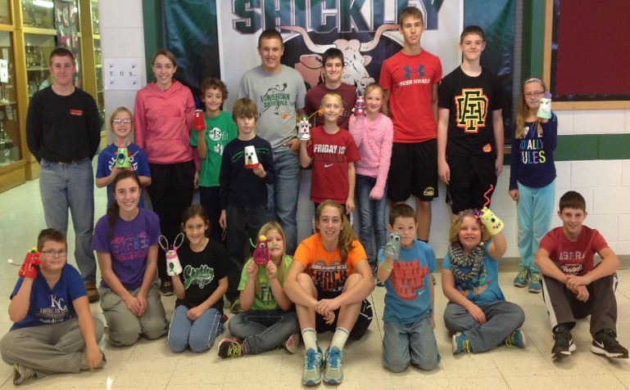
The Information Technology class is pictured with the third grade students and their character cups they created.

Kindergarten News

During the month of December, the Kindergarten class had a lot of fun doing various gingerbread activities. They read several books which usually involved the children loudly repeating the familiar phrase, “Run, run as fast as you can. You can’t catch me I’m the Gingerbread Man!” The children also decorated foam gingerbread men ornaments for the class Christmas tree.

Another favorite activity they did was making gingerbread houses. This was a two day project. The first day was spent putting the houses together with graham crackers and frosting. The next day they added candy decorations to the houses. It was fun to see the students’ creativity come alive. There were smartie shingles, candy cane trees, marshmallow chimneys, and colorful siding. Thank you to all the parents for providing the supplies to make our gingerbread houses.

There were also daily letters from the Gingerbread Man. The class eagerly listened each day as these letters were read to them by Mrs. Schoming. One day the Gingerbread Man even showed up in class. He remained very still so that he did not disrupt the class.

The kindergarten class would like to say a huge thank you to Mrs. Schoming for being their substitute teacher while Mrs. Schultz was gone. The class enjoyed having her teach them sight words, touch math, expand their writing skills, and many other things.

The kindergarten class is pictured with the gingerbread houses they made.

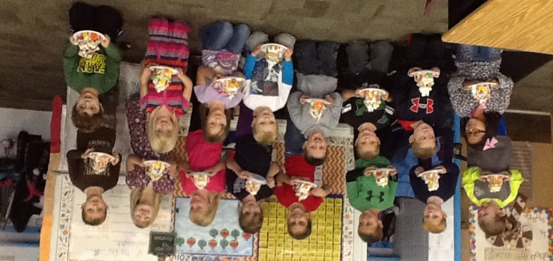

Thank You for your Donations

The FBLA and FFA Coat, Boot, and Food Drive was very successful this year. The first grade class joined in the drive and donated several boxes worth of food and goods, including toys. It was great they chose to share what they had with those who are less fortunate. The drive took place for a little over two weeks. The amount of goods donated was amazing. We were able to donate 116 pounds of canned goods and over 100 winter clothing items. This drive wouldn’t have been a success without all those who so generously donated. Thank you.

Pictured is Nathan Hendrickson loading up some of the donated items to take to Blue Valley in Geneva.

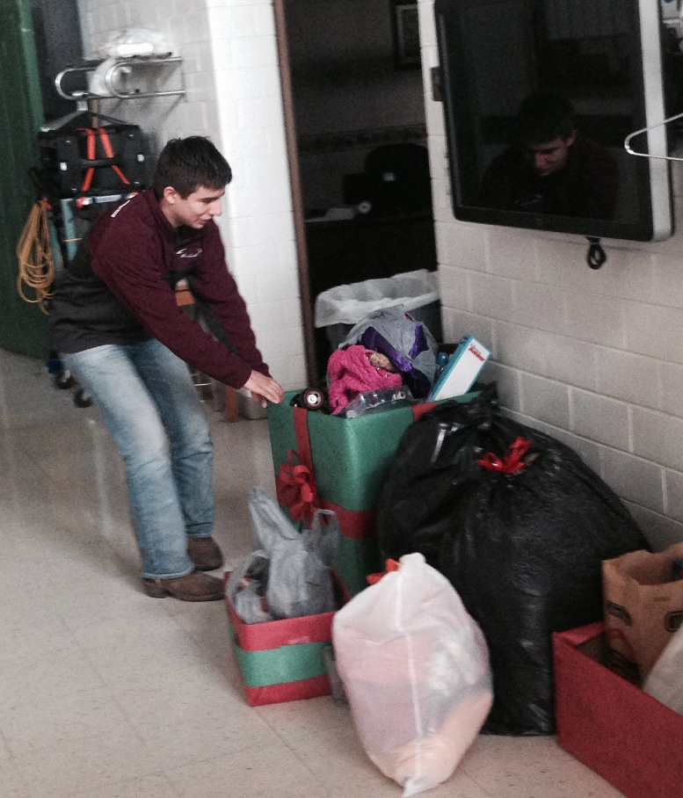

Christmas Concert

Shickley Public Schools 5th-12th grade bands and 7th-12th grade choirs performed at the annual Christmas concert. The concert was held on Monday, December 15th, at 7:00. The groups performed an array of music from traditional styles to a more modern mix. The ensembles were under the direction of Joshua R. F. Harris and were accompanied by Judy Lichti.

At the concert the high school was recognized by the Nebraska Music Educators Association with a Participation Award. This award is given to programs with high percentages of enrolled students participating in the music department.

Following the concert, the Music Boosters provided cookies, cider, and punch for everyone who came to enjoy the concert.

Pictured is the 5th and 6th grade band.

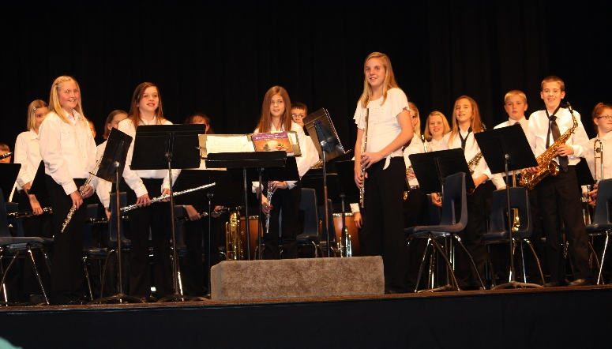

Letter from Mr. Ippensen, Principal

“Without continual growth and progress, such words as improvement, achievement, and success have no meaning.” - Benjamin Franklin

At Shickley Public School, it is our mission to prepare students for success, and it would be fair to ask the questions, “How do you do this? How do you measure this?” While we have a number of attributes designated as those of a successful student, one of the biggest ways we are able to determine if we are truly preparing our students for success is by checking for continual growth and progress. Testing has received a bad rap in both the local and national news, but at Shickley, we are able to take the data from this testing, and use it to help us work with each student in his or her individual areas of relative weakness. Instead of leaving no child behind, we focus on preparing each student for success.

As always, if you have any questions or comments regarding the work we are doing at Shickley Public School, or if you would like to share in the process of preparing our students for success, please don’t hesitate to stop in and talk, or give us a call.

Derek Ippensen
PK-12 Principal

