Hoofprint
Shickley Public School

…preparing students
for success…

November 2014

Monthly Newsletter

Notes from Mr. Jorgenson
November brings a lot of changes. Outdoors, the leaves are falling and the temperature usually changes more dramatically. In the public arena, everyone is preparing for Christmas, and the importance of the celebration of Thanksgiving becomes smaller and smaller. As we turn to November, it is important to reflect on the things that we are thankful for. As a country, state, town, and school, we are privileged to many things. It is very easy to overlook the everyday luxuries that we have and it can be hard to remember to be thankful. Personally, I am very thankful for my wife and children. I have made them move several times for my career and through it all, they have persevered. The excellent staff, students, and parents we have here at Shickley are something that I am very grateful to be able to work with. There are always those moments in life that can challenge your thankfulness and cause you to feel negative about what is going on around you. However, at least in my case, the good outweighs the bad.
I am really proud and thankful of what we are doing here at Shickley Public Schools. Let me give you an example. In a conversation with someone over Labor Day, we were talking about what schools can offer their high school students. It is important to note that the person I was talking to was from a place where they have 900 students K-12. They began to tell me that the only advanced class offered at their school is Advanced Placement Math. However, they are able to offer a wider variety of classes in the areas of Family Consumer Science and Industrial Technology. So then I began to tell her what Shickley has to offer. I told her that we offer two classes of Math for dual credit, meaning that they receive high school credit but they are receiving college credit for it, too. I went on to describe that we have two English classes available for dual credit as well. Students also have the option of enrolling into a Career Academy. Nursing, preschool, agriculture, and welding are just a few of the areas that students can enroll in for this program. All of the work that they complete for this program they also receive dual credit for. Additionally, students at Shickley can take a number of online college classes from Peru State College and Southeast Community College. So you can imagine how this person was feeling. There is a stereotype that a small school cannot offer as much as a large district, and in some cases that is true – but not at Shickley.
In closing, do not believe the myth that small schools cannot offer their students a quality education. Our students are very prepared for what they may encounter after leaving these walls. In fact, to those who are extra motivated, they can have more than a semester of college done when they graduate from Shickley Public School. Yes, they may not receive as wide a variety of classes, but we are still able to prepare students for success in whatever they choose.
Very thankful,
Bryce Jorgenson
Superintendent
bjorgenson@longhornpower.org

You have brains in your head. You have feet in your shoes. You can steer yourself any direction you choose.
-Dr. Seuss

4th Grade News

The 4th grade class completed their science unit on Technology and The Designing Process. They learned how technology solves problems and makes work easier. Each student got a first-hand chance to design their own hovercraft. By trying different size balloons they were able to predict which size would make their hovercraft travel farther. Some changes had to be made to help improve their traveling distance. To complete the unit, each student designed paper airplanes with different shapes and sizes of wings. They found out that some designs did not work as well as others.
Pictured is the 4th grade class and their teacher, Mr. Sorge. They are testing their paper airplanes in the gym.
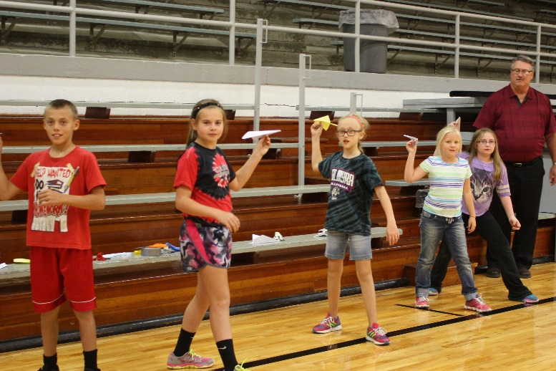

FFA at Land Judging
On Wednesday, October 8th, Sophomore Shickley FFA members attended the Land Judging contest in Deshler, Nebraska. The Land Judging contest was put on by the Little Blue Natural Resource District with support from the Natural Resources Conservation Service. Over 200 students competed in the contest representing 15 different schools. The following members participated for Shickley: Chris Lichti, Courtney Kamler, Kale Kleinschmidt, John Alfs, Carley Swartzendruber, and Dakota McBride. They had to determine the land capability class and conservation practices for four different sites. Out of all the participants only the top 40% receive individual ribbons. John Alfs received a red ribbon, while Dakota McBride and Chris Lichti both received white ribbons.

The Scholastic Book Fair is coming to school November 17th-21st. It will be held in the Music Room this year. Family night will be Tuesday, November 18th, from 4:00-7:00.
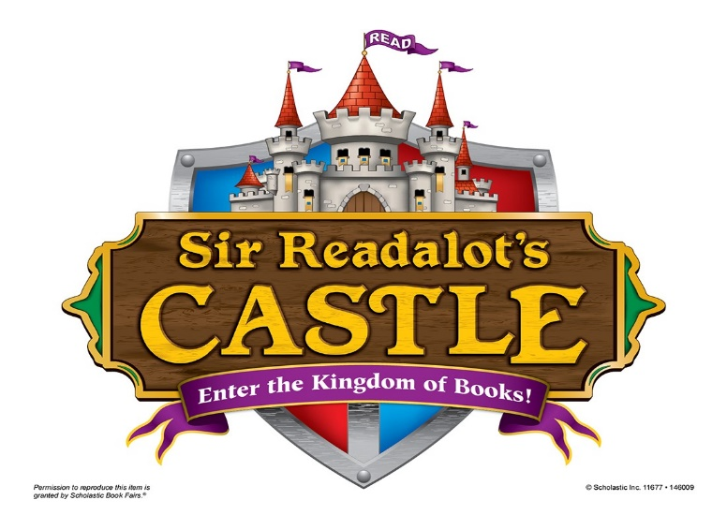

Band marches at Harvest of Harmony Parade

The Shickley Marching band performed at the Harvest of Harmony parade and field competition Saturday, October 4th. Shickley performed Thriller, YMCA, Let It Be, and Hey Jude. The band is under the direction of Mr. Harris and Drum Major Kristin Troyer.
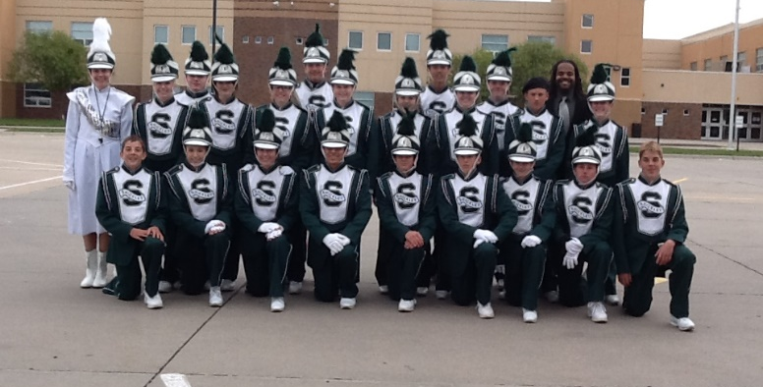

1st Grade News
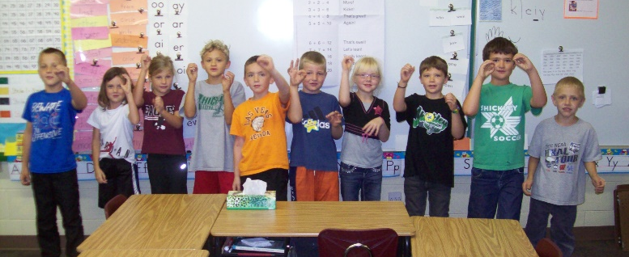
First graders doing the “Doubles Rap.”
The first graders have been working very hard learning their doubles facts in math. They sing the “Doubles Rap” daily to help them learn the concept faster and easier. In writing they have been having conferences with their partner to help them revise and edit their stories. Science experiments are always a big hit in first grade. They learned how to make their own “tornado” using pop bottles. The children are also learning about their skeletal system and some of their internal organs. Critical thinking is a big part of their lessons as they have to figure out the purpose of each part. In reading the students have been taught many letter clusters to help jump start their skills. They enjoy using the actions that they have learned for each one and are beginning to apply what they have learned when decoding new words.

Fifth grade art on exhibit
The Nebraska Art Teacher Association’s Student Exhibit was held on September 25th-26th in Aurora, Nebraska. Art educators from across the state entered artwork from two students. The artwork was on display at the Leadership Center in Aurora. Representing Shickley in the exhibit were fifth graders, Mariah Sliva and Tyler Grote. They created paper collages inspired by “Molas” created by the people of Panama. Pictured below is the artwork of Tyler Grote (left)and Mariah Sliva (right).

Freshmen Physical Science Experiment
Science teacher, Miss Henning, has been teaching the Freshmen Physical Science class about energy. The students created machines that had to show how different types of energy were used. There were two teams. The team with the wooden catapult went the furthest but only by a little bit. This was a great learning experience for the students and they really put a lot of time and effort into their machines.
Pictured are members of the freshmen class testing their machines on the football field.

Preschoolers have been busy!
The Shickley Preschoolers have been very busy! They have been learning about friendships, colors, numbers, and letters. They also celebrated Fire Prevention Week by taking a field trip to the fire station. They were able to go on the fire truck, try on the fire fighters’ gear, see all of the equipment, and hear the “LOUD” siren! They got to experience the fire station first hand and had a great time. Thank you to the Shickley Volunteer Fire Department!
Preschoolers are at the fire station with Fireman Den. 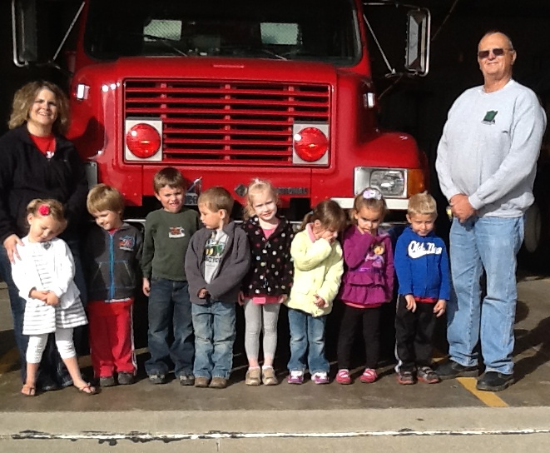

High School English/Language Arts

High school English/Language Arts students in Mrs. Ippensen’s classes have been quite busy during the first quarter of this year. While all of these classes aim to increase students’ knowledge and develop their skills in reading, writing, speaking, listening, and multiple literacies, their approaches are varied.
Senior English students are taking Appreciation of Literature this semester, which is offered for dual credit through Peru State College for those who wish to take the class for college credit. Literary elements they are studying include Point of View, Character, Plot, Setting, and Theme. At the end of each unit, students write about a particular element in relation to one of the works of literature they have been studying. Later in the semester they will read The Great Gatsby and compose a final essay in which they discuss one of these literary elements.
As a part of their recent unit on Media Literacy, junior English students were asked to create electronic research collections based on topics of their choice. Their final products have been published as “Pages” on Facebook. These students located, evaluated, and selected information from a variety of online sources and explored numerous media such as text, pictures, graphs, charts, videos, and other appropriate material they uncovered through their research. They practiced utilizing Diigo, a social bookmarking and information organizing tool which allows users to bookmark, highlight, annotate, save, and share digital copies of online sources. They then created Facebook Pages where they posted their findings, along with a summary and response for each source.
In English, the sophomores learned about plot development, characters/characterization, setting, point of view/narrator/ voice, and theme during our unit on short stories and the elements of literature (with a focus on fiction). For the unit project, their goal was to help others gain a better understanding of each of the elements of literature they studied throughout this unit and those elements within the context of a particular piece of literature. In their Beginning Speech class, the sophomore students have been learning about the process of communication and how to prepare and present speeches. Recently they presented speeches about how to do something, how to make something, or how something works.
During their unit “Reading for High School and Beyond,” the freshmen each determined what benefits them the most before, during, and after they read. Each student then developed a presentation to share with others that clearly describes his or her Personal Reading Procedure. Their goal was to express what they do during each phase of reading and also clearly describe how to use each of their strategies, include examples, and explain why each strategy is beneficial.
As you can see, much of what these students have been working on is intended to share with a broader audience. You are invited to see some of their writing, projects, and presentations on the school website.

One-Act Cast and Crew Prepare for Upcoming Season
Shickley’s one-act play production this season is Sherlock Holmes in Wonderland by Geff Moyer. In this comedy-mystery mash-up, crucial items have gone missing in Wonderland. The infamous crime solving duo of Sherlock Holmes and Dr. Watson find themselves kidnapped and delivered to the Queen of Hearts who demands that they discover what has been stolen and by whom. People of all ages are invited to join in the fun as our detectives meet the likes of the White Rabbit, the Mad Hatter, and the Cheshire Cat. Find out if they will solve the crime in time, or if they will lose their heads on the chopping block! The play will be performed for the public during Longhorn Arts Night on the evening of Monday, November 10th.
Cast members are Rio Mohrmann, Logan Rosenquist, Bret Smith, Kristin Troyer, Catherine Mick, Tristen Mosier, Courtney Kamler, Chris Lichti, Lexi Kadel, Megan Grote, and Nicole Swartzendruber. Carley Swartzendruber is assisting with directing and Nathan Hendrickson is heading up the technical crew which includes Madison Yantzie, John alfs, Wyatt Deepe, Victoria Escalera, Jackson Grote, Caleb Hendrickson, Isaac Kamler, and Josiah Kamler.
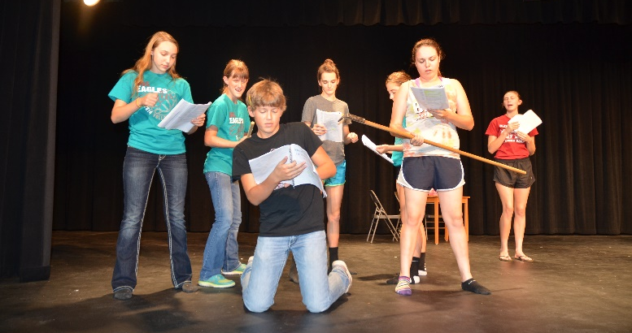
While rehearsing a scene, Card Guards Nicole Swartzendruber, Lexi Kadel, Catherine Mick, Megan Grote, and Axman Logan Rosenquist surround Sherlock Holmes (Chris Lichti) as the Queen of Hearts (Kristin Troyer) speaks her mind behind them.

FFA Helps with Harvest Bonanza
This October, Shickley FFA members partnered with KUTT to feed producers as they hauled grain to the local elevators. Shickley members volunteered at the Carleton and Shickley bonanza locations. They were in charge of preparing the hot dog meal and handing out goodie bags as trucks arrived. Megan Swartzendruber, Caleb Hendrickson, Isaac Kamler, Josiah Kamler, Wyatt Deepe, and Caitlin Mosier served as volunteers. Harvest Bonanza is a great way for FFA members to give back to their rural community during the busy harvest season. Pictured below is Josiah Kamler filling the goodie bags.
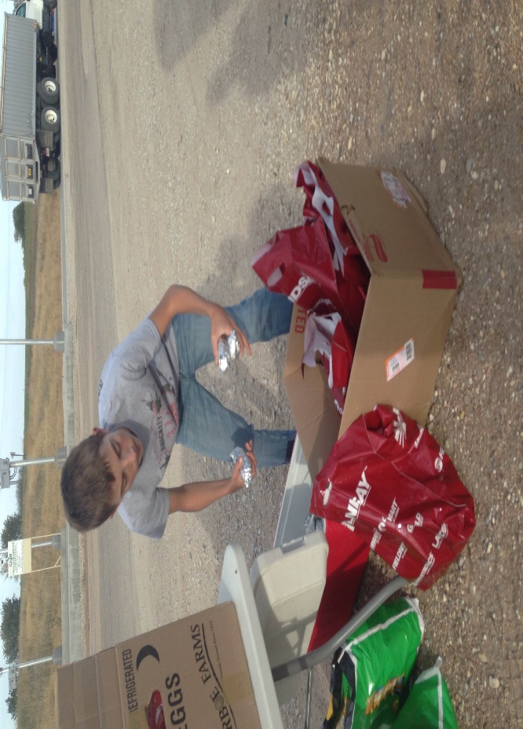

BDS Junior High Volleyball

From the start of the season, the goal for the BDS Junior High Volleyball team was to be one of the two teams in the CRC Championship game. With a season of marked improvement in several categories, the Eagles achieved this goal and played in the CRC Championship game.

The Eagles journey to the CRC Championship game was amazing, although it didn’t end as the team had hoped. The Eagles ended their season as Conference Runner-ups and with a record of 12-2.

The BDS Junior High B Team had a great season as well. They played some very tough competition and ended their season 9-3.

Congratulations ladies and coaches on a great season!

BDS Junior High Football

BDS Junior High Football season concluded recently with a 22-16 win over Harvard. The game was exciting as the score indicates. The Eagles battled back late in the 2nd half to capture this victory.

The Eagles finished their season with a 4-2 record. The reserves record was 0-1. The young Eagles learned many lessons during the year including the importance of hard work, passion, and teamwork not only in football, but their other endeavors as well.

Letter from Mr. Ippsensen, Principal
W
Lewis Carroll, author of Alice in Wonderland, wrote, “If you don’t know where you are going, any road will get you there.” He was right. If we are going to set our sights on preparing students for success, we need to know how to get there.
We believe that offering a challenging, relevant curriculum, aligned from Preschool to 12th grade is a key to success. Over the past couple of years, we have been making changes to the curriculum, some of which were noted last month. But mentioning them doesn’t give whole picture; the best way to see it is to visit the school website or click on the link below: http://tinyurl.com/ShickleyCurriculumGuidebook.
The Shickley Curriculum Guidebook is a complete curriculum guide containing course descriptions and unit plans, as well as graduation requirements, and college and career readiness information in the curriculum section. There are also assessment and instruction sections, as well as professional development and school improvement sections. The Curriculum Guidebook provides a deeper and more open set of information for students, parents, and the community.
As always, if you have any questions or comments regarding the changes happening at Shickley Public School, or if you would like to share in the process of preparing our students for success, please don’t hesitate to stop in and talk, or give us a call.
Derek Ippensen
PK-12 Principal

