## 

## 

Hoofprint

Shickley Public School

…preparing students

for success…

May 2015

Monthly Newsletter

**Notes from Mr. Jorgenson**

At the end of the year, people tend to reflect on what worked and what didn’t work. Once these have been examined, we turn our focus to the next school year and begin planning and preparing. Currently, we are in that stage as administrators. One thing we are working on is evaluating what needs to be done with the swimming pool. You should have received your survey on the swimming pool, and the information we are asking for is very valuable to us. As a district, we want to move forward using the results from the survey. Please turn in those surveys as soon as possible so that we will have time to evaluate them.

Also, in April, we lost a great member of our staff. Pat Swartzendruber had an impact on many people in and outside of Shickley. Her years of service for our youth, whether it was working with the preschool kids or helping in anyway, will have an impact on the generations to come. As a district, we are glad that she was a part of our journey through life. We will continue to keep her family in our thoughts and prayers.

Lastly, remember that we have Shickley’s Awards Night on May 7th, at 7:00 P.M.; the Class of 2015 will cross the stage on May 17th, at 2:00 P.M.; and the last day of school is May 20th. As the Seniors depart, a quote from Dr. Seuss comes to mind, “You’re on your own. And you know what you know. And YOU are the guy who’ll decide where to go.” Good luck to the graduates and as you leave our school and your homes, you truly are the ones who control where you go from here.

Bryce Jorgenson

Superintendent

[bjorgenson@longhornpower.org](mailto:bjorgenson@longhornpower.org)

**Shickley Speech Team Competes at State**

Duet Acting partners Kristin Troyer and Chris Lichti walked away as champions when Shickley’s state qualifiers competed in the Class D2 NSAA Speech Championships on the University of Nebraska-Kearney campus on Friday, March 27, 2015. Troyer was also the runner-up in Entertainment, while Lichti finished 7th in the same event. Coach Jennifer Ippensen said, “I am so impressed with these two. They demonstrated the qualities of true leaders and great teammates throughout the season, by continually striving to improve and supporting each other, and their efforts paid off.”

Shickley’s other qualifying entries in the state contest included Catherine Mick (8th place) and Megan Swartzendruber (10th place) in Informative Speaking and Nathan Hendrickson (15th place) in Extemporaneous Speaking.

Pictured are Kristin Troyer and Chris Lichti performing their duet.

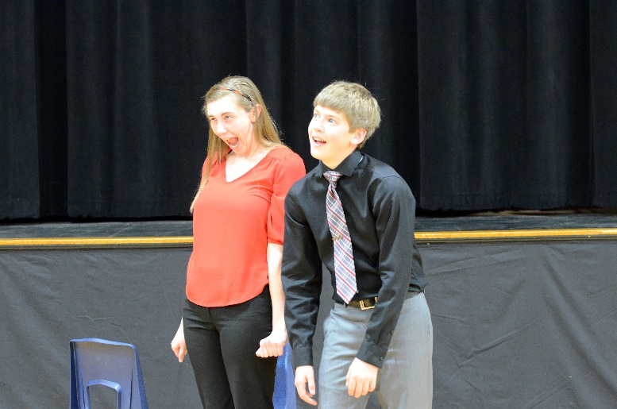

**Fourth Graders Win American Legion Essay Contest**

In an effort to encourage America’s schools to promote patriotism and democracy so that future voters will be inspired to keep alive the United States’ long and well-respected tradition of a government “of the people, by the people, for the people,” the American Legion Auxiliary annually sponsors an Americanism Essay Contest for students in grades 3‑12.

Under the leadership of teacher Dan Sorge, the fourth grade class at Shickley Public School accepted the Legion Auxiliary’s challenge, writing essays utilizing this year’s theme, “What does freedom mean to my family?”

Each student wrote a thoughtful essay, discussing topics ranging from American soldiers fighting for freedom to the freedoms outlined in our Bill of Rights to America’s farm families being free to manage their operations without undue government influence.

Hannah Miller, daughter of Dan and Sarah Miller, and Ashley Schlegel, daughter of Scott and Sherri Schlegel, tied for second place while Brianna Jorgenson, daughter of Bryce and Rebecca Jorgenson, took home the top prize. Brianna’s essay, which discussed what freedom meant specifically to her grandparents, to her parents and to herself, will be forwarded on to compete in the State Americanism Essay Contest.

Congratulations to the winners and to all the fourth grade students for demonstrating how well they understand the importance of freedom in America!

Pictured are Brianna Jorgenson, Hannah Miller, and Ashley Schlegel.

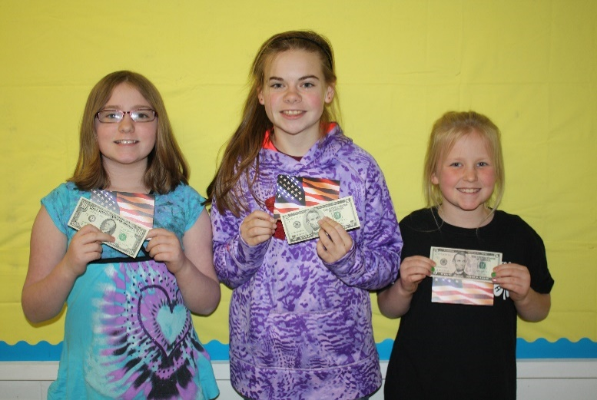

**Project Based Assessment in Third Grade**

The third grade wrapped up another chapter in both social studies and science. In science they learned about lava, magma, earth’s crust, and igneous rock. They tested their skills by making volcanos and they loved seeing the reaction! In social studies, students discussed their own unique family tree of five generations. Miss Johnson really loves seeing student engagement and excitement during these project based assessments. “I love seeing the kids get excited about learning!” she exclaimed.

Pictured below are Cloey Carlson with her family tree and Seth Stengel with his volcano.

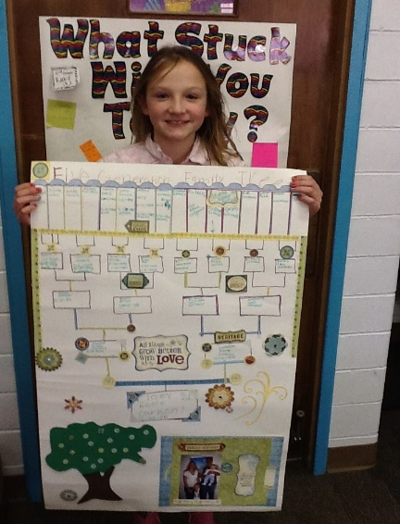



**Child Find for Special Education Services**

Do you know a child of five years of age or younger who may not be developing appropriately because of difficulties with: seeing or hearing, sitting, standing, walking, thinking, or behaving appropriately? Call 402-627-3375 if you are served by Shickley Public Schools.

Parents or guardians of children with special needs, from birth through the age of 21 years, can receive special education services. The testing and education services are of no cost to the parent. The service is provided through Nebraska School Law and Public Law 94-142. Anyone having a child with a disability in the Shickley School District may contact school administration at 402-627-3375 for details.

**Class D All-State Band**

Twelve students performed with one student assistant at the Class D All-State Bands at the University of Nebraska-Kearney campus. There were two concert bands and one jazz band, comprised of students from across the state of Nebraska.

Pictured are back row, left to right: Tristen Mosier, Catherine Mick, Megan Grote, Thomas Mick, Kristin Troyer, Nicole Swartzendruber, Chris Lichti, and Mr. Harris. Front row: Bret Smith, Logan Rosenquist, Lexi Kadel, Kellen Reinsch, Anthony Beavers, and Nathan Hendrickson.

~~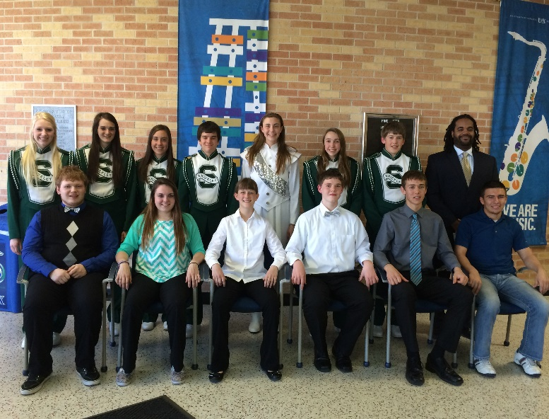~~

**Speakers Compete in Modern Woodmen Competition at Majestic Grand Theater**

Shickley had six students compete at the district level of the Modern Woodmen Speech Competition on April 8th, at the Majestic Grand Theater in Hebron. There were six schools represented at the competition. In the elementary division, fifth grader Taylor Sliva placed third. In the junior high division, Regan Alfs also placed third.

Pictured below are our six students who competed: (back row) Caitlin Mosier, Regan Alfs, Kaylee Noel; (front row) Mariah Sliva, Taylor Sliva, and Blake Schlegel.

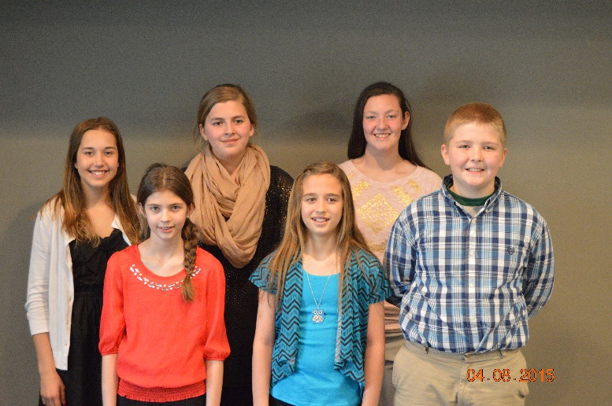

Friday, May 8th

Science Fair

in main gym

9:00 A.M. to 11:00 A.M.

Elementary Fun Day

on football field

1:00 P.M.

**Title News**

Summer is fast approaching and it’s never too early to start planning summer reading activities. Your child has worked on strengthening his/her reading skills all year long; you don’t want to lose those skills over the summer! Here are a few tips and ideas from the *Parent Institute* to get you and your child’s summer packed with reading!

Seven Ways to Prevent Summer Reading Loss:

1. **Read together daily.** In addition to reading books, ask for your child’s help with following recipes, looking up information online, and making lists.
2. **Keep reading materials handy**. Leave comics, magazines, books, newspapers, and other materials around the house where your child is likely to pick them up.
3. **Choose irresistible materials.** Look for books and articles about your child’s interests, such as sports, art, fashion, or even a favorite movie.
4. **Talk with experts**. Ask your child’s teacher or a librarian for summer reading suggestions.
5. **Visit the library regularly.** Give your child frequent opportunities to find materials that appeal to her.
6. **Take books with you.** Bring them on trips, into waiting rooms, and anywhere else your child might complain, “I’m bored!”
7. **Be creative.** Listen to audio books. Play word games. Visit a museum and read about displays. Start a book club.

There are countless ways you can encourage your child to maintain — and even improve — his/her reading skills during vacation. Feel free to start using the above list now!

Amanda Hansel

Title I Teacher

**Dual Credit Agribusiness Now Offered at Shickley Public School**

Ms. Kristin Witte and Shickley Public School recently received approval to add a new dual credit class offering to its curriculum: Agribusiness Management. In conjunction with Southeast Community College, juniors and seniors will now be able to take Agribusiness Management for high school and college credit at Shickley.

When courses are offered as dual credit, students are able to take the course while in high school but earn college credit at the same time. In our efforts to prepare students for success at the next level of their education and in their careers, these dual credit courses are a great way to get a head start on their education, and at a discounted price, too! An additional benefit for the students is the ability to take dual credit courses with teachers they know and are familiar with.

Students at Shickley Public School currently have the option to take a number of courses for dual credit and college credit. Through Peru’s Early Entrance program, students can take courses online for college credit. Southeast Community College and the University of Nebraska-Lincoln also offer similar programs. Through SENCAP, SCC’s career academy program, students are able to take up to four courses in preparation for further training for a career in education, health, or information technology to name a few. Finally, students are currently able to take four dual credit courses through Peru State College, and now the new Agribusiness Management through Southeast Community College, on campus here in Shickley.

**36th Annual FFA Banquet**

On Tuesday, March 24th the Shickley FFA held their 36th annual banquet. The banquet was attended by family and friends of the Shickley FFA. The Discovery Degree was presented to the following 8th grade members: Caleb Hendrickson, Isaac Kamler, Josiah Kamler, Jadyn Kleinschmidt, Terry McBride, and Caitlin Mosier. The Star Discovery Degree was awarded to the most active member of the 8th grade class which was Caleb Hendrickson. First year high school members were awarded the Greenhand Degree. Those members receiving this degree were: Anthony Beavers, Wyatt Deepe, Carley Elznic, Lexi Kadel, Thomas Mick, Kellen Reinsch, Holden Stengel, Jacob Swartzendruber, and Nicole Swartzendruber. The Star Greenhand was awarded to Holden Stengel. Members who received the chapter degree received the highest degree the chapter can give them. The following members were awarded the chapter degree, John Alfs, Courtney Kamler, Kale Kleinschmidt, Chris Lichti, Dakota McBride, Rio Mohrmann, and Carley Swartzendruber. The Star Chapter Degree was given to John Alfs. Top fruit salesmen were recognized for their hard work and dedication. Those who were recognized were: Caleb Hendrickson, Caitlin Mosier, Anthony Beavers, Kellen Reinsch, Jacob Swartzendruber, John Alfs, Courtney Kamler, Carley Swartzendruber, and Samantha Plock. Students who were recognized as individuals in each agricultural education class with the highest grade point average were given Scholarship pins. Recipients were: Kellen Reinsch, Nicole Swartzendruber, Courtney Kamler, Ben Elznic, Blake Stengel, Megan Swartzendruber, and Rio Mohrmann. Leadership pins were awarded to members in each class who have shown their leadership skills within the Shickley FFA chapter. Awards were given to: Holden Stengel, John Alfs, Carley Swartzendruber, Kale Kleinschmidt, Tristen Mosier, Catherine Mick, Nathan Hendrickson, Ben Row, Samantha Plock, and Crayton Mosier. The Outstanding Member Award was given to Blake Stengel for all his involvement in the chapter. The

Outstanding Leader Award was presented to Nathan Hendrickson for being a great role model for younger members. The Honorary Chapter Degree was awarded to Scott Schlegel for all his support of the chapter and his willingness to serve as a judge for numerous contests. The 2015-2016 officers were installed as chapter leaders. Officers are: Courtney Kamler-President, Kale Kleinschmidt-Vice President, Nicole Swartzendruber-Secretary, John Alfs-Treasurer, Carley Swartzendruber-Reporter, Caleb Hendrickson-Sentinel, Holden Stengel-Parliamentarian, Isaac and Josiah Kamler-Executive Officers. The 2014-2015 school year was very successful, and we look forward to a great 2015-2016 FFA year.

Pictured below are the members at the banquet.

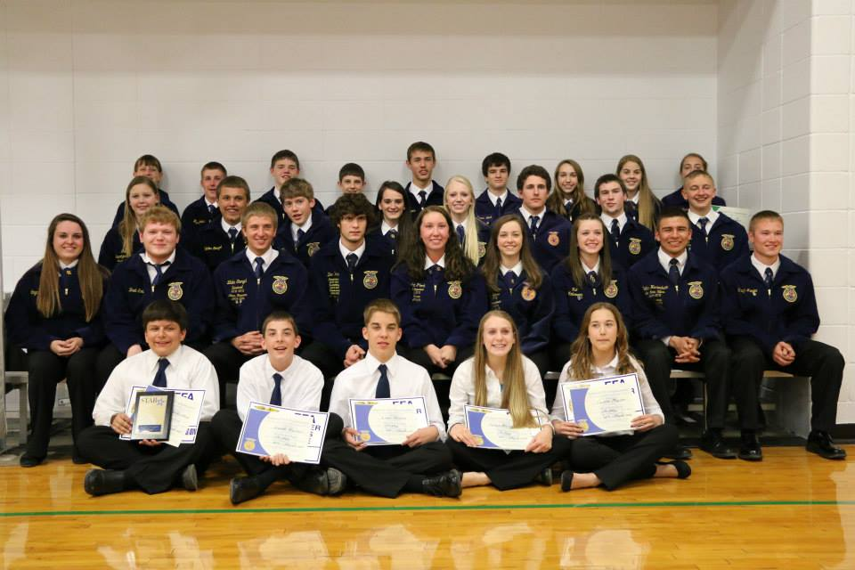

Pictured below are next year’s officers.

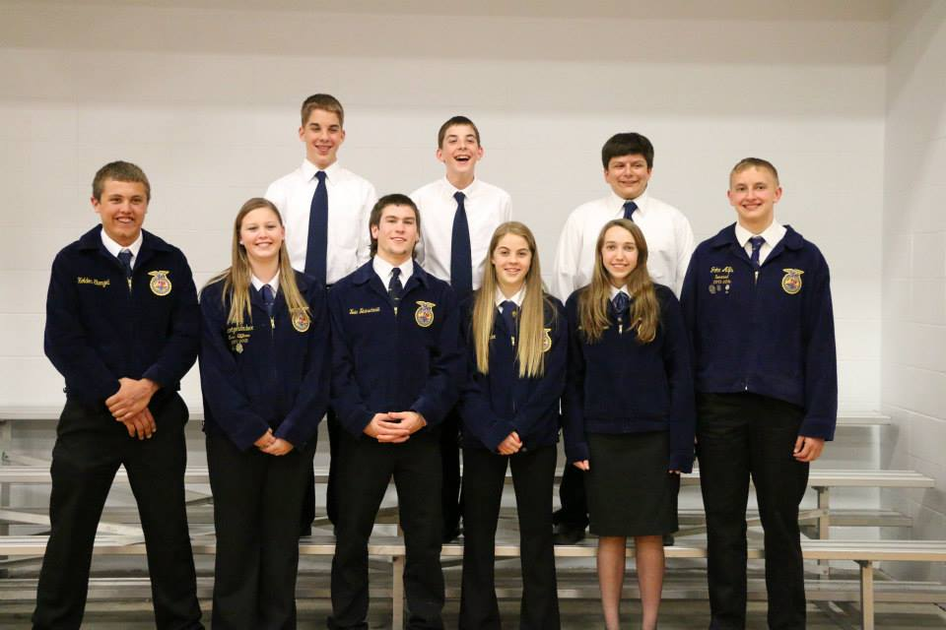

**Language Resource News**

One of my favorite quotes, “Children are made readers on the laps of their parents," by Emilie Buchwald, brings a smile to my face each time I hear it. As an educator I always valued that quote but as a parent it means so much more. Some of our most memorable moments with our daughters have come while spending that short bit of time together reading a story. Children young and old seem to enjoy hearing stories, whether read from a book or a story shared about traditions or the past. In all instances, we are able to be taken to new places and have new experiences. With those new experiences come the opportunities for children to hear and use new “language.” New vocabulary, grammar, sentence structure, and many more language experiences happen without notice. The benefits are unmeasurable for all.

As you are reading or listening to stories, feel free to ask your child questions about the story. Some ideas would be: *How would you change the story if you were the author? If you could be one character in the story who would it be and why? Would you feel the same way if that happened to you?* Anything you can do to get your child talking about the story is great, even if it leads to more than the storyline itself. Another activity would be to act out a part of the story. Children could even write their own parts of the story as an author or draw their own pictures like an illustrator. The sky is the limit. Remember, there is no age limit when it comes to hearing a good story! “I'll love you forever, I'll like you for always, As long as I'm living my baby you'll be.”- *Love You Forever*, by Robert Munsch.

Have a wonderful summer!

Merissa Zajic – Language Resource

Anita Blum- Speech Language Pathologist

**Meridian Honor Band and Choir**

Our junior high band and choir students auditioned to be part of the Meridian Honor Band and Choir. We had seven choir students and two band members selected to participate. They performed in Meridian on Friday, April 10th at 7:00 P.M.

Pictured below are those students selected to participate: (front row) Brooke Jorgenson, Caitlin Mosier, and Josh Swartzendruber; (back row) Caleb Hendrickson, Alyssa Nolt, Jadyn Kleinschmidt, Mr. Harris, Kaylee Noel, Isaac Kamler, and Josiah Kamler.

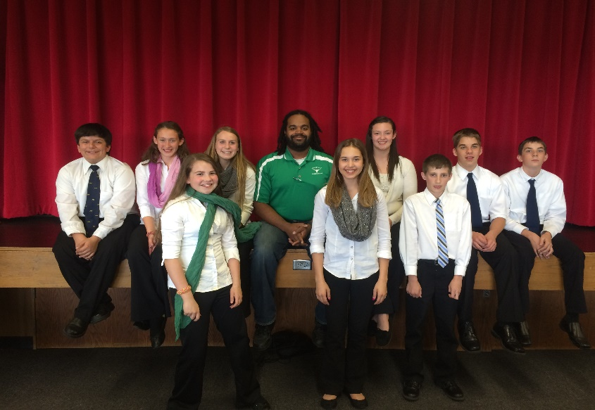

**Mark your calendars to attend the**

**Shickley Awards Night**

**On Thursday, May 7th**

**at 7:00 P.M.**

**Supper will be provided.**

**Educators Health Alliance**

The teachers and staff at Shickley Public School started a new journey with the EHA program. The program is offered by the Educators Health Alliance (EHA - who provides our BCBS insurance).

The EHA wellness program is so much more than just physical wellness.  The six main areas of wellness the program will provide include:



Bi-monthly challenges geared toward these six areas of wellness are set up for member participation. Currently, the teachers and staff are embarking on a virtual challenge across Alaska in the Iditarod. The challenge started March 30th and will end May 10th. Exercising 30 minutes, eating 2 servings of vegetables and 3 servings of fruit, and getting 7-9 hours of sleep are requirements of completing this 6 week challenge. The staff was able to sign up as a team or individually. We are proud say that we have 6 teams of 6 participating in the challenge!

We didn’t stop there though…to take the challenge even further, we set up a school challenge where those teams are tracking their daily steps and are in competition to reach the finish line first. When you are in the building, feel free to check out the bulletin board by Joyce’s office to see the teams and their progress! You could say that we truly are taking “strides to a healthier you!” You will see the staff

wearing their pedometers and you may witness some taking a quick lap around the gym during their lunch

or plan time. I’ve even seen Mr. Jorgensen and Mr. Ippensen make a lap in the lobby! Little adjustments and some friendly competition can make a big difference in a person’s overall wellness.

This first year in the program has been a success and we look forward to next year as we take on new challenges and continue to work on keeping ourselves healthy and well so we can be the best we can be.

Merissa Zajic and Katie Johnson

Shickley EHA Coordinators

**Students Achieving AR Goals**

April has been an exciting month for achieving reading goals! The students within Miss Hansel’s classroom have worked very hard to reach new astonishing reading marks on their story passages. Each student started the month with a reading goal. After each week’s new story, students compared their scores to see if they improved. If the students passed their mark, a new egg was added to the board. Look at all those eggs!

Pictured below are Lauren Richards and Lynley Swartzendruber adding their eggs to the board!

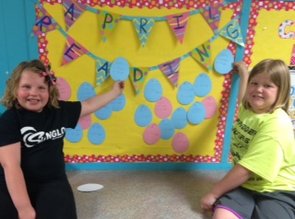

**ESI**

**CAMP 2014**

**June 18 & 19, 22 & 23**

**Grades 5th – 7th**

**Brochures will be sent home with students**

**\*Registration deadline May 11th**

**\*Limited participants**



**Shickley Nebraska**

**Entrepreneurship Investigation (ESI) Camp**

**Contact: Mrs. Yantzie**

**(402) 627-3375**

**kyantzie@longhornpower.org**

**Legion Auxiliary Poppy Poster Contest**

Students in grades 2, 3, 5, and 6 created posters for the American Legion Auxiliary Poppy Poster Contest. The posters will be displayed at a future time around town. Three finalists were chosen, and their posters will be sent on to compete at the state level. The finalists who are pictured below are: Division I, 6th grader Briana Janing; Division II, 5th grader Taryn Fiala; and Division III, 2nd grader Hayley Sliva. Congratulations to these students for their designs and craftsmanship.

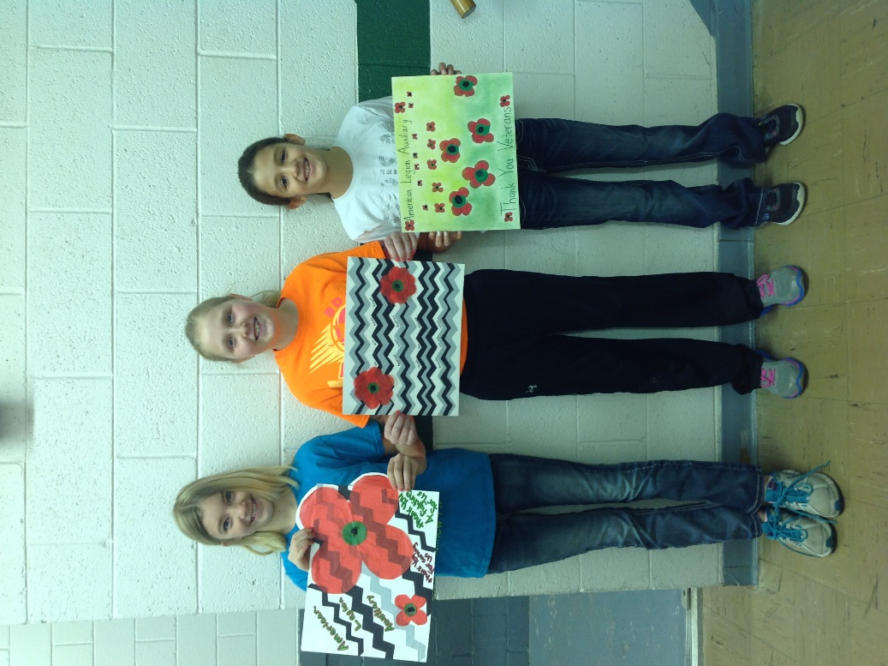

**Hatching Chickens in Fourth Grade**

The 4th grade class finished up their embryology study of chickens with the arrival of 52 baby chicks on April 15 & 16.  They had anxiously been waiting for 21 days for the chicks to hatch.  They became familiar with the parts of an egg as well as the different parts of a grown chicken.  Everyone was amazed how a fluffy chick could come out of the small egg.  Even after one day out of the shell they could see the wing feathers starting to show up.  The students who received permission from their parents were able to take chicks home to care for and watch them grow.

Pictured are the 4th graders with their chickens.

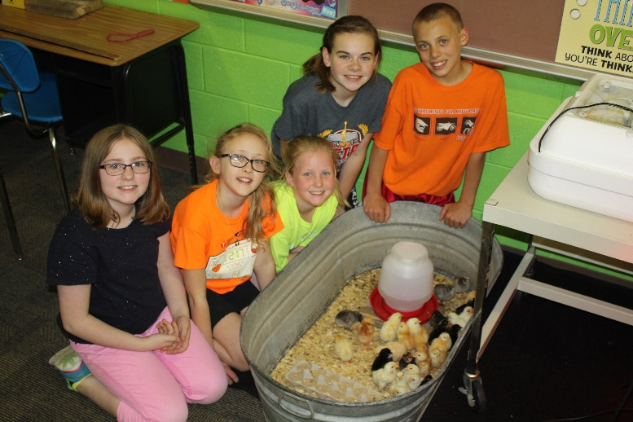

**Thank You for Supporting Plant Sales**

Shickley’s Third Annual Plant Sale was a success! We sold over $22,000 in pre-sale orders and grades 7th-11th made nearly $8,000 profit. The students and their sponsors want to thank all of the customers who bought plants from us and the parents who supplied incentives for the students.

A special thank you goes out to the community members who helped the day of the sale.

**FFA Attends State Convention in Lincoln**

The Shickley FFA Chapter attended the Nebraska State FFA Convention April 8th-10th in Lincoln. The chapter competed in several different events and had 24 high school members in attendance. Throughout the convention four members sang at all the general sessions as members of the Nebraska State FFA Choir. They were: Carley Elznic, Anthony Beavers, Chris Lichti, and Ben Elznic. The freshman competed in the AgriScience Fair contest, where they developed and completed scientific research relating to agriculture. AgriScience Fair participants were: Nicole Swartzendruber, Lexi Kadel, Carley Elznic, Wyatt Deepe, Holden Stengel, Kellen Reinsch, Anthony Beavers, Thomas Mick, and Jacob Swartzendruber. Nicole Swartzendruber was alternate for the Plant Systems Division I. Thomas Mick and Jacob Swartzendruber won the Environmental and Natural Resources Division III, which will allow their research report to be sent to the national contest. Competing on the 7th place Ag Sales team were: Blake Stengel (tied for 4th purple), Tristen Mosier (blue), Catherine Mick (red), and Ben Elznic. The Farm and Ranch Management team also placed 7th overall. Team members were: Nathan Hendrickson (15th purple), Blake Stengel (Purple), Rio Mohrmann (blue), and Ben Row (red). In the Natural Resources contest Megan Swartzendruber (purple), Chris Lichti (red), Kale Kleinschmidt, and Samantha Plock received a white ribbon. The AgriScience team received a white ribbon. Team members were: Kellen Reinsch (white), Lexi Kadel, Nicole Swartzendruber, and Thomas Mick. In the Food Science contest Megan Swartzendruber (purple), Courtney Kamler (red), Kellen Reinsch, and Samantha Plock competed. The following members competed in the Biotechnology contest: Courtney Kamler, Chris Lichti, Ben Row, and Crayton Mosier. The Meats Judging team was: Carley Swartzendruber, John Alfs, Kale Kleinschmidt, and Jacob Swartzendruber. In the Agronomy contest the following members competed: Jacob Swartzendruber (white), Thomas Mick, Wyatt Deepe, and Holden Stengel. On Friday the 8th grade members came to convention to compete in Quiz Bowl and People in Agriculture. Those members were: Josiah Kamler, Isaac Kamler, Jackson Grote, Caleb Hendrickson, Caitlin Mosier, and Jadyn Kleinschmidt. Caleb Hendrickson also competed in the Discovery Speaking contest where he received a bronze rating. At the last session of convention six Shickley FFA members received their State Degrees. State Degree recipients were: Nathan

Hendrickson, Blake Stengel, Ben Row, Crayton Mosier, Samantha Plock, and Megan Swartzendruber.

When members weren’t busy competing in various competitions they attended a variety of educational sessions. They enjoyed the convention and all it had to offer.

Pictured are those members who attended all three days of convention.

.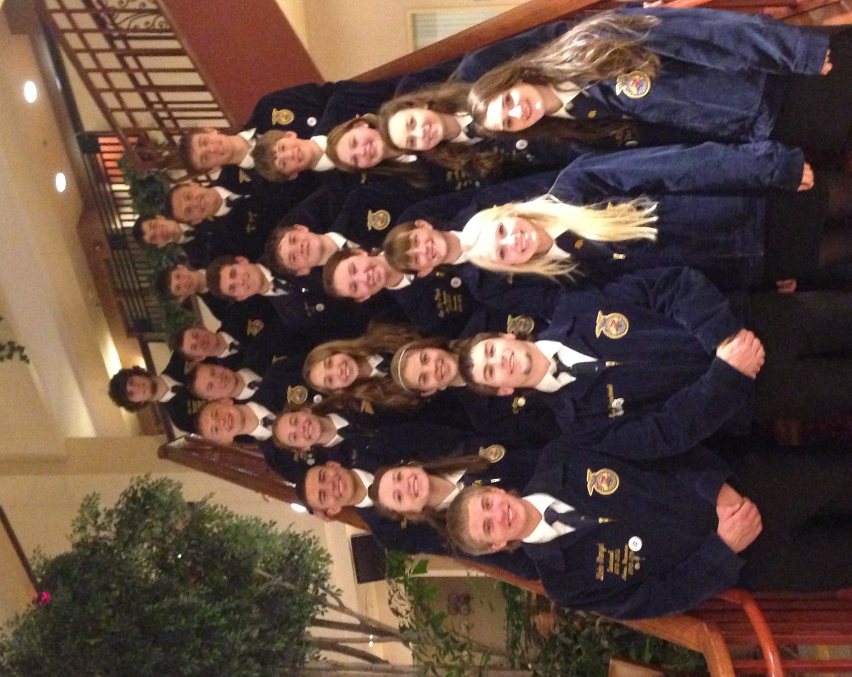

Pictured below are the 8th graders who attend convention.

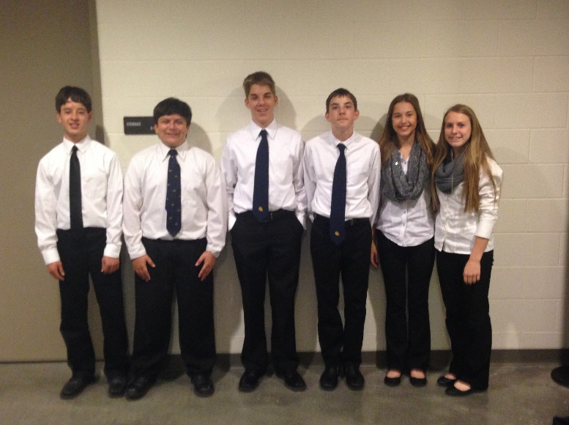

**FBLA Attends State Convention in Omaha**

Ten students attended the FBLA State Leadership Conference in Omaha on April 9-10th. This was the first year for the eighth grade members to attend the conference. They attended the general session on Thursday with keynote speaker, Patrick T. Grady. Each student competed in numerous comprehensive business events on Thursday and Friday. The chapter received 2nd place for the Largest Percentage Increase for chapter membership. They received ribbons for their completion of the Go Green, Feed Nebraska, and March of Dimes projects and a Seven Up ribbon for having seven new members. Caleb Hendrickson received honorable mention in Spelling. John Alfs won the Client Service event and will represent Nebraska at the National Leadership Conference in Chicago in June. Additional students who attended were—Rio Mohrman, Madison Yantzie, Carley Swartzendruber, Jackson Grote, Issac Kamler, Josiah Kamler, Jadyn Kleinschmidt, and Caitlin Mosier. Mrs. Yantzie received her 10-year award.

Pictured below are some of this year’s convention attendees: Mrs. Yantzie, Carley Swartzendruber, John Alfs, Rio Mohrmann, and Madison Yantzie.

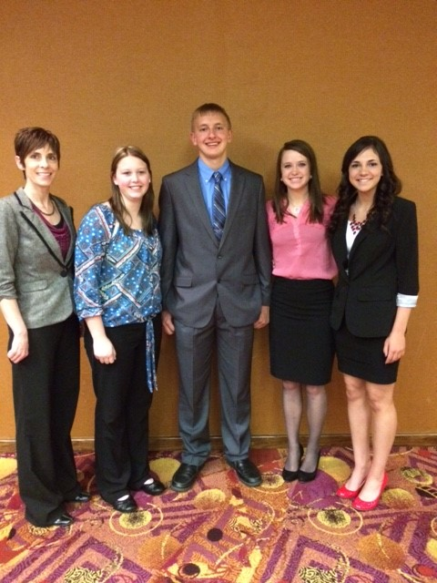

Preschool Graduation

will be held

Tuesday, May 12th

at 1:00 P.M.

in the main gym.



**FBLA Easter Egg Hunt**

The FBLA Chapter assisted with Annual Community Easter Egg Hunt. The students filled plastic eggs with candy, tattoos, and sticky toys. The Easter Bunny arrived in Shickley on April 1st at the city park. Children pre-school age through 4th grade hunted for the candy & prize-filled eggs. A girl and boy from each age group won an Easter basket filled with a variety of toys and candy. The event was sponsored by the Shickley Community Club with the assistance of the Shickley FBLA chapter.

Pictured below are kindergarteners ready to start hunting for eggs.

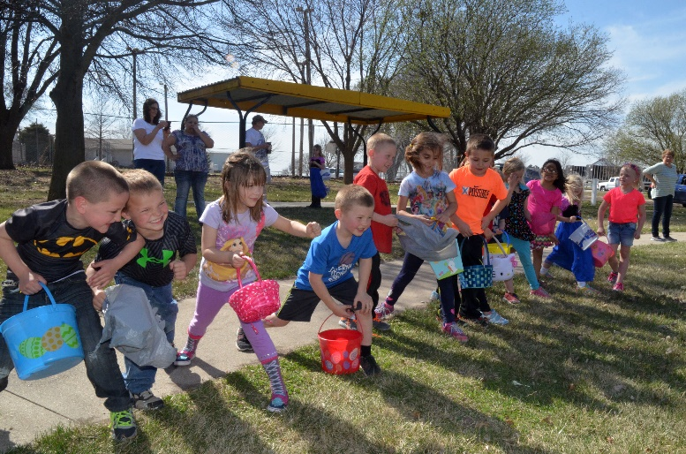

**Celebration of Academic Success**

The 2015 Spring Celebration of Academic Success will be held on Thursday, May 14th at 2:30 in the gym. At this ceremony, students are recognized for their continued academic development and achievement. Students in Kindergarten through grade 12 will be recognized for their efforts.

Please come help celebrate the academic effort and accomplishments of our students on May 14th.

**Agriculture Notes from Miss Witte**

It’s hard to believe that we are already to the month of May; it seems like we just started school last month. As my second year winds down here at Shickley Public Schools, I am excited for what the future holds. Summer is often seen as a time for vacation and no school, but for me I see it as a time to work on curriculum and think of new ideas to try in the classroom. This year I have been able to use the Curriculum for Agriculture Science Educators (CASE) Animal Science materials because of a training I attended last summer. This curriculum is designed to teach students through inquiry based learning. It has several assignments that have students apply what they learn to an animal they select at the beginning of the semester. The CASE material also gives students an opportunity to dissect different animal tracts and see what we have been talking about in class for themselves. I continue to look for ways to develop hands-on and meaningful curriculum, and I appreciate the support of the school board and administration as I do this.  Although summer is here, the learning doesn't have to stop!

**Foster Grandparents Honored**

Grandma Nancy Hanouw received a Foster Grandparent certificate as well as a 5-year pin for volunteering to work with the elementary students at Shickley Public School. The Foster Grandparent program, which started 50 years ago, held a celebration for all of the area foster grandparents. A luncheon was provided by Aunt Mary’s in Beatrice. Former foster grandparent Ethel Johnson was also recognized for all of her dedication.

Pictured are Nancy Hanouw and 1st grade teacher Mrs. Nelson, who is the volunteer station coordinator for Shickley Public School.

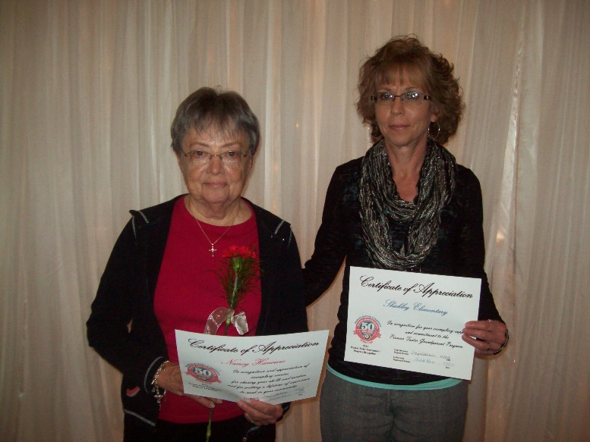



Graduation 2015

May 17th at 2:00 P.M.

in main gym.

**Mrs. Schultz Earns K-3 Math Specialist Certificate**

Kindergarten teacher, Mrs. Shultz, enrolled in Primarily Math and earned a K-3 Math Specialist Certificate. Primarily Math is an 18-credit hour graduate program for teachers of kindergarten or grades 1, 2, or 3 that leads to earning a certificate as a K-3 Mathematics Specialist.

Teachers take three courses focused on pedagogy and children’s mathematical development from UNL’s Department of Teaching, Learning, and Teacher Education and three mathematics courses especially designed for teachers from the Department of Mathematics.

Mrs. Schultz said that the program was intense, but very worth taking. “Participating in this program was the smartest decision I have made since becoming a teacher,” she said. “I would tell anyone considering any additional professional development, especially Primarily Math, that they should absolutely go for it.”

Mrs. Schultz has taken what she learned in this program back to her classroom and is also sharing it with other teachers. “I enjoy sharing what I have learned with my colleagues and offering advice to new teachers,” she said. “The teaching philosophy of our school involves lots of collaboration with our peers to help guide our instruction. The other teachers are aware of my participation in Primarily Math, and they approach me if they have questions or need some suggestions to guide their math instruction.”

Our 5th Annual 5K Fun Run/Walk

will be on

Wednesday, May 20th

Registration at 10:30 A.M.

5K starts at 11:00 A.M.

**Letter from Mr. Ippensen, Principal**

In *A Midsummer Night’s Dream*, William Shakespeare wrote, “Though she be but little, she is fierce.” In the play, he was describing Hermia, but he could have just as easily been writing about Shickley Public School.

Sometimes, it is evident that our students are prepared for success, and this year has been one of those times. Often, we choose to measure ourselves against those closest to us – local schools and our conference – and when we do so, it is clear that we are not only competitive, but successful. But when you take a larger view, and look at our performance across the state and even nationally, the success – the fierceness, if you will – becomes evident. We have had great success in our athletic and fine arts activities this year – often competing as the best in the state. Academically, we regularly find our students performing in the highest 25th percentile, which is exceptional – we even have whole classes performing at these high levels. This level of competition and performance is at the heart of preparing our students for success – when they compete with the best, they excel.

As always, if you have any questions or comments regarding the work we are doing at Shickley Public School, or if you would like to share in the process of preparing our students for success, please don’t hesitate to stop in and talk, or give us a call.

Derek Ippensen

PK-12 Principal