Hoofprint
Shickley Public School

…preparing students
for success…

March 2015

Monthly Newsletter

Notes from Mr. Jorgenson
Spring is just around the corner. From green grass to spring rains, it is a great time to see the world around us change and show more life. At my desk, the spring brings a time to figure out and plan what we need to do to “bring new life” to our facilities and to discuss what changes we need to make with the teachers and the students.
In the fall, the school had an engineer come in from Miller and Associates of Kearney to evaluate the current condition of the pool. One of the reasons for doing this is that we have been experiencing a large amount of water loss the last couple of summer seasons. We may have found part of the problem, but the evaluation goes much deeper into the current state of our pool. As a school, we would like to discuss with the public the results of the study in a public meeting. We have scheduled a meeting on March 30th, at 7:00 P.M., to be held in the gymnasium. The engineer of the project will be there to make a presentation and give a chance for everyone to ask questions about the pool. We would also like to gather some input from the public. After the meeting, a survey about the future of the Shickley pool will be constructed and sent out to all the patrons. It was built in 1970, so it will be 45 years old this summer. According to the engineer, it is reaching its life expectancy. In planning for the future, as the Superintendent, I would like to have a plan of action for how we will move forward with the pool. So if you can make it, please plan on attending our meeting concerning the swimming pool.
Bryce Jorgenson
Superintendent
bjorgenson@longhornpower.org

Sometimes the questions
are complicated
and the answers are simple.
-- Dr. Seuss

Modern Woodman Speeches

The 5th-8th grade students are currently researching and developing their Modern Woodmen Speeches. This year’s topic is “An Interesting Landmark.” The landmarks can be buildings, monuments, and other structures of geographic features that are easily recognizable or historically significant. The landmark can be either nationally recognizable or locally known. The in-class competition will be March 17th and the in-gym competition will be held on April 2nd, beginning at 8:15 A.M.

Annual Plant Sales

The 7th-11th grades will be having their annual plant sale during the month of March. You can order from any student in those grades and their class will profit from the sales. You can also go online and order at www.janetsjungle.com.

B.O.C.H. Festival
Kristin Troyer, Chris Lichti, Nicole Swartzendruber, and Carley Swartzendruber were selected to the B.O.C.H. Festival hosted by the University of Nebraska-Omaha January 23rd-25th. The students sang with other students from across Nebraska and western Iowa. The final selection was a combined piece consisting of the honor band, orchestra, and choir. Shickley’s participating students are pictured with Mr. Harris below.
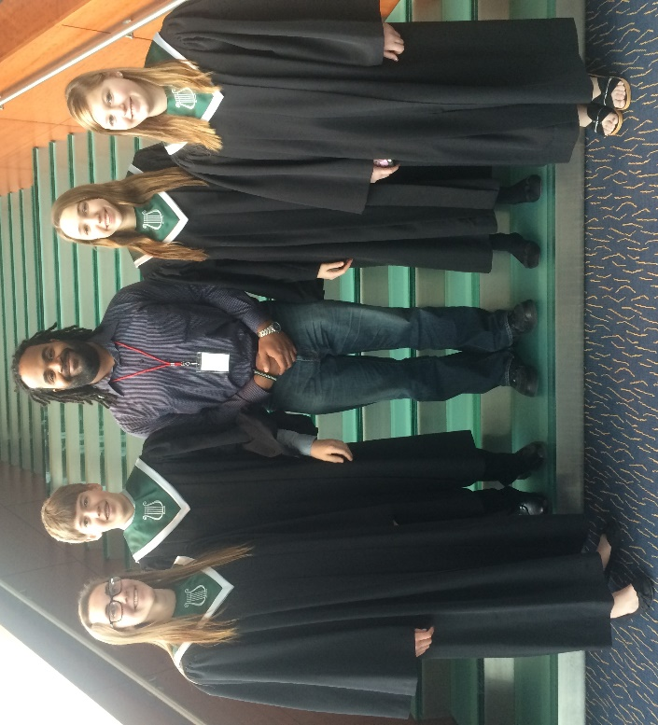
UNK Honor Festival
Kristin Troyer and Chris Lichti we selected to perform at the University of Nebraska-Kearney Honor Festival on Monday, January 26th. There were 3 choirs and 2 bands. Students were from Nebraska and Kansas. Pictured are Kristin Troyer, Mr. Harris, and Chris Lichti.
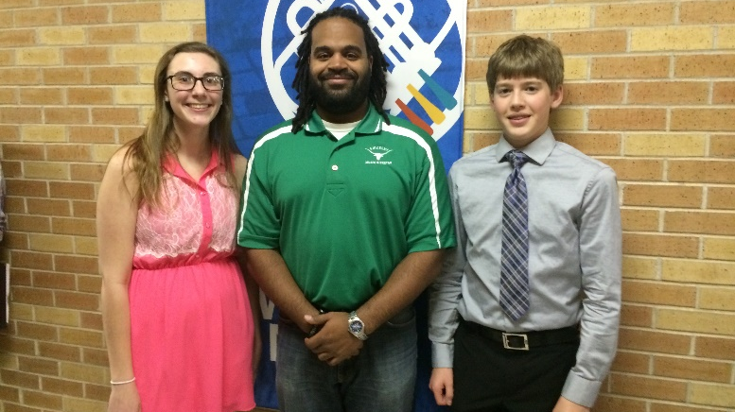

BDS Junior High Boys’ Basketball
The BDS boys’ junior high basketball team wrapped up their season with a 10-1 record the end of January. By winning all four of their southern CRC conference games they earned the right to play the north division winner at the York City Auditorium for the second year in a row. The northern conference representative was Shelby/Rising City. They proved to be too much for the Eagles who had to settle for the runner-up trophy, losing 44-25.
“I was really proud of the effort the kids showed all season,” commented co-coach Greg Schroeder. “We really didn’t know for sure what to expect from our junior high team that didn’t return any starters from a year ago, and really only one or two kids that played much at all. They worked hard all season and can really be proud of the effort they showed to get back to this game.”
Pictured is the junior high boys’ basketball team with Coach Kluck and Coach Schroeder.
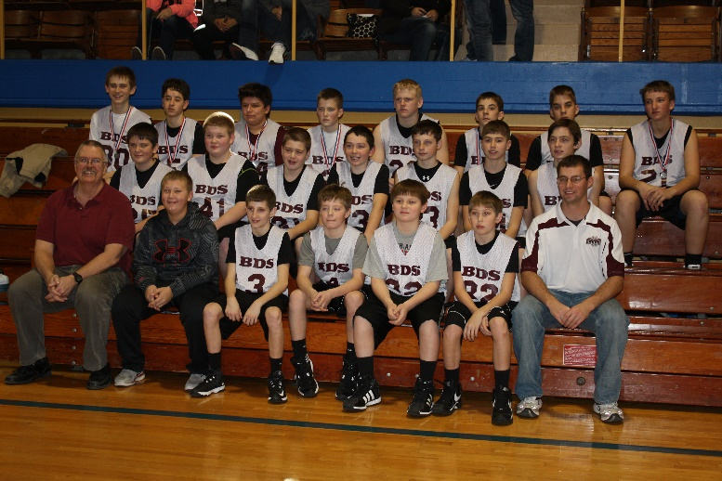

BDS Junior High Girls’ Basketball
The 2014-2015 BDS junior high girls’ basketball team had a total of ten girls out this year. It was a nice mix of 7th and 8th graders with five in each grade. They played a total of twelve games and ended with a record of 9-3, which included an undefeated B division conference record. They also placed 2nd at the Dorchester tournament, 1st at the Exeter-Milligan tournament, and were the Crossroads Conference Champions. Their main goals at the beginning of the season, however, were to work hard every day, get better from week to week, and increase the players’ basketball IQ. They made some big strides at improving in all three areas. By the end of the year all the girls not only grew together as a better team, but they grew exponentially as individuals in their basketball skills.
Pictured is the junior high girls’ team with Coach Swartzendruber and Coach Schlegel.
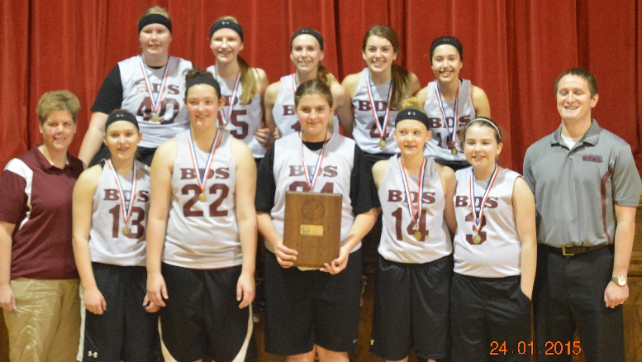
Wesleyan Honor Choir
Chris Lichti and Kristin Troyer were selected to the Wesleyan Honor Choir held February 12th-14th. There were students from across Nebraska represented in the choir. Chris and Kristin are pictured with Mr. Harris.
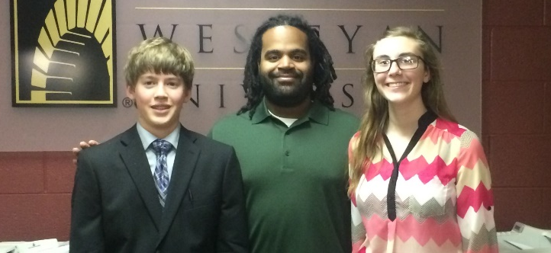
Guidance Counselor Notes
One of the most fun parts of school is having the chance to spend time with friends. Knowing how to build friendships is a skill worked on in guidance time with Mrs. Noel. Throughout the school year, classes have learned what it takes to be a good friend, such as telling the truth, resolving conflicts appropriately, communicating with each other, and avoiding negative peer pressure. Learning about these important skills is accomplished by projects, playing games, and learning from each other.
In the picture below the 6th grade class is playing “Pretzel.” It is a game which utilizes communication skills, teamwork, and cooperation.
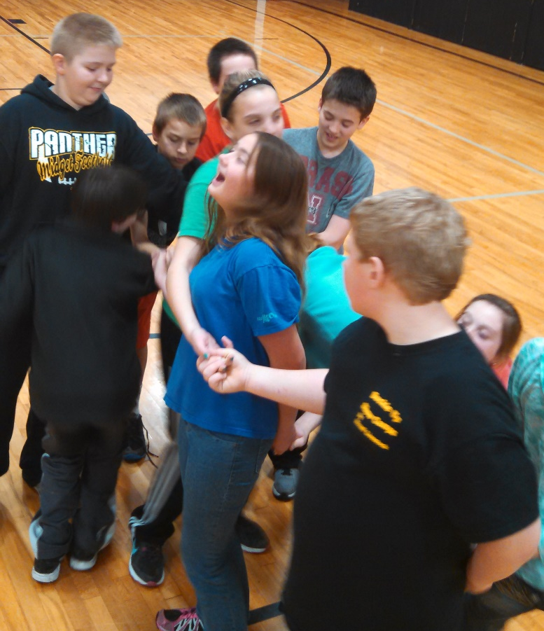

Language Resource News
It’s that time of year when studying math facts, sight words, or just plain studying is becoming “boring” or monotonous. You might be experiencing some resistance from your child and you might be catching yourself feeling the same way. Don’t worry…the special service team has a couple of suggestions that might add some excitement back into your evenings! Here are a couple of games you could play using any set of math fact cards or a set of index cards.
- War or Highest Cards Gets It: Divide the deck of fact cards evenly among players. Each player keeps their stack face down in front of them. The first player flips over his/her card and says the fact and answer. The next player does the same. Whoever has the highest number wins the round and gets both cards. If there is a tie, each player flips over 3 additional cards (saying the fact and answers.) The player with the highest on the third card wins the round and gets all of the cards played that round. Continue play until 1 player has won all of the cards. (This could also be played using Dominoes tiles.)

- Memory or Go Fish: These will work better for sight words or spelling words but feel free to adapt to meet your child’s needs. For Memory or Go Fish you will need to make a set (two cards) for each word using index cards or any colored or thicker piece of paper. Mix the cards and either lay them out for memory or deal 5-7 to each player, leaving the extras in the middle as the “fish pond.”
- For Memory, encourage your child to read each card as they flip it over and, of course, there might be times when mom and dad need to help with reading their words.
- For Go Fish, take turns asking for the cards you need. If a player gets a match, he/she gets another turn. Continue playing until all the cards are gone. The player with the most matches wins.

Remember to always be “good sports” and end the game with a friendly shake and “good game.”

Feel free to share any unique ideas you have for making studying FUN at home. We would be happy to use them at school and to share them with others. Thank you for all you do at home to help your child be successful.

Merissa Zajic
Language Resource Teacher

Spelling Bee Winners

Recently the Spelling Bee was held in grades 5-8 to determine who would go on to compete in the County Spelling Bee held in Geneva at the Courthouse on February 12th. Those who won locally and got to go on were 5th grade: Madeline Kamler, Taylor Sliva, Tyler Grote, and Eli Noel; 6th grade: Nolan O’Brien, Reid Richards, Macy Kamler, Aaron Mick, and Blake Schlegel; 7th grade: Brooke Jorgenson, Alyssa Nolt, Kaylee Noel, Raegan Fiala, and Zach Mosier; 8th grade: Caleb Hendrickson, Josiah Kamler, Jadyn Kleinschmidt, and Isaac Kamler.

February 12th proved to be a great day to be a speller from Shickley Public School. We had four of our students bring home trophies. They are pictured below: Madeline Kamler 1st place in 5th & 6th grade division, Brooke Jorgenson 3rd place in 7th & 8th grade division, Josiah Kamler 2nd place in 7th & 8th grade division, and Caleb Hendrickson 1st place in 7th & 8th grade division.

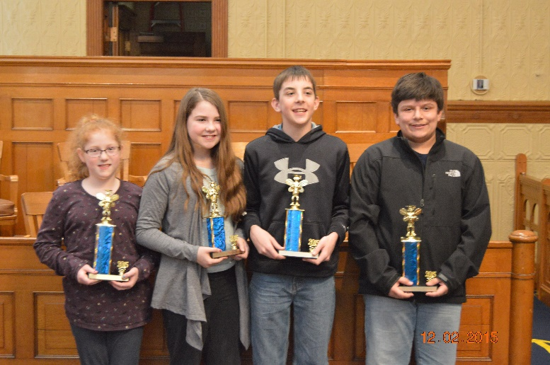

Bruning-Davenport Music Contest

Congratulations to all of the elementary and junior high students who performed at the B-D music contest. The students all played well and represented Shickley well. The elementary concert band performed and earned straight 1s from all the judges. Congratulations to all the fine musicians, and thank you, students, for all of your hard work.

Art Department News

The Art Department has been busy creating art this year, which can be seen in the hallways or on our online gallery at Artsonia.com. This fall, two fifth graders had artwork displayed at the NATA (Nebraska Art Teacher Association) Conference in Aurora, Nebraska; Congratulations to Mariah Sliva and Tyler Grote for the outstanding work on their paper “Molas” project. Elementary students also drew contest posters for school nutrition. Every art student K-12 had artwork displayed at Fine Arts Night. Thank you to the parents and community for your attendance at the event. It meant a lot to the students to share their talents with you!

Later in the fall two high school art students had artwork displayed at the NASB (Nebraska Association of School Boards) Conference November 19th-21st in LaVista, Nebraska. The quality artwork that was shown at the conference was a charcoal drawn tiger by Madison Yantzie and an oil painting of a flower by Megan Swartzendruber. High school art students are currently working on entries for the Congressional Art Contest.

March is Youth Art Month, also known as YAM. Two students will have artwork on display at the state capitol in Lincoln. They are second graders Hayley Sliva and Stella Ippensen (pictured below.) They will be given awards in a YAM ceremony on Saturday, March 21st at 2:00 P.M. in the Capitol Rotunda.

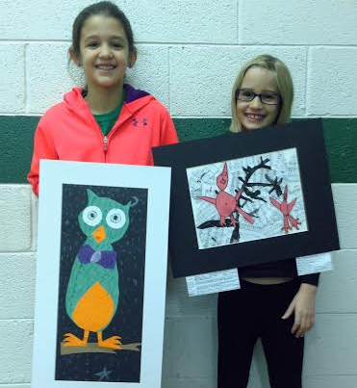

Finally, thank you to everyone who has donated bottle caps. We are now done with a 4-foot by 8-foot mural of two human forms in silhouette in motion in front of the four elements: land, water, air, and fire. Pictured below are the 8th grade students attaching plastic caps to this year’s mural on the left; last year’s mural is shown on the right.

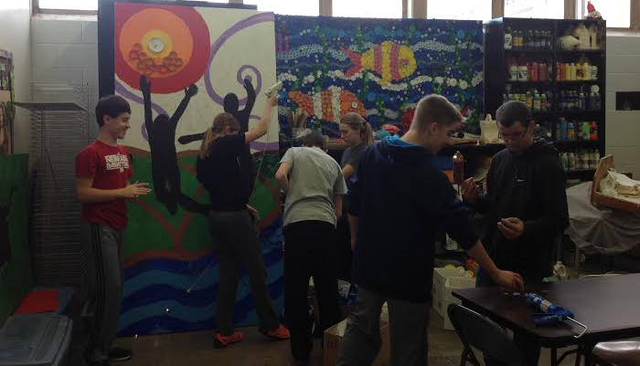

Fifth Grade News

It has been a busy year in the Shickley 5th grade classroom. The students have been enjoying getting to talk about their days every morning and learning about each other and what each other’s interests are. Recently, we have been studying fractions in math. We know how to create fractions, turn improper fractions into mixed numbers and back again, simplify fractions, find equivalent fractions, and turn decimals into fractions in their simplest forms. This also includes knowing about what factors are and how to find common factors of numbers, which leads to helping in simplifying the fractions. We have been biologists in science as we have been learning about the parts and functions of plants and animals. We have also been looking at different adaptations made by plants and animals so that they can survive in their different environments. In January, our writing also picked up as we started preparing to give our first speeches for the Modern Woodmen competition. This year’s topic is “An Interesting Landmark.” We are finishing the research stage of some landmarks and are beginning to write about them. Our in-class competition, when we give the speeches, is coming up in March. The Fillmore County Spelling Bee was held February 12th and our very own Madeline Kamler came home with a first place finish, and Tyler Grote also finished in the top 5. Finally, we are excited to welcome a new student into our class, Haden Sittler. He joined us the end of January.

Shickley Celebrates FBLA Week

by Samantha Plock, FBLA Reporter

Future Business Leaders of America (FBLA) students at Shickley joined others across the state during the week of February 8-14 to celebrate FBLA Week. This week provides members the opportunity to demonstrate how FBLA educates members in the fields of business, technology, and career skills. Moreover, members showed their appreciation for the FBLA as they continue to “Ignite Innovation.”

The special activities held this week included the “Jammies for Babies” fundraiser for the March of Dimes. Students and Faculty donated money to wear pajamas to school. This activity raised $170.00 for the March of Dimes. March of Dimes is the leading nonprofit organization for pregnancy and baby health and is dedicated to improving the health of babies by preventing birth defects, premature birth, and infant mortality. FBLA has been involved with the March of Dimes for more than thirty years and continues to be the largest youth fundraiser for the March of Dimes.

The FBLA chapter promoted their “Going Green” project by holding a poster contest for the 5th and 6th grades, asking a Shickley recycling center trivia question, providing daily “Going Green” facts, and wearing green to school.

The winners of the FBLA “Go Green” poster contest were 5th grade: Mariah Sliva 1st; Landon Johnson 2nd; Madeline Kamler 3rd. 6th grade winners were: Aaron Mick 1st; Macy Kamler 2nd; Reid Richards 3rd. Mr. Harris was the winner of the “Go Green” trivia question. Each winner received a Cubbies gift card.

The chapter concluded the week by volunteering at the Hastings Crossroads Center Rescue Mission. The students assisted with preparing lunch, unloading a truck with donated food items, and going through food inventory. The students were given a tour of the mission and gained a better understanding of the importance of volunteering.

Members had a good time celebrating FBLA week and completing their activities!

Pictured below are faculty and students who participated in “Jammies for Babies” on February 13th.

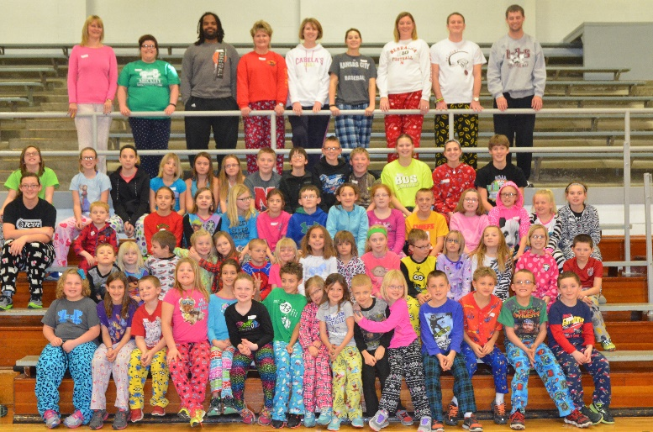

Students wore green to show their support for FBLA “Go Green” project. Pictured below are the daycare kids and their teachers.

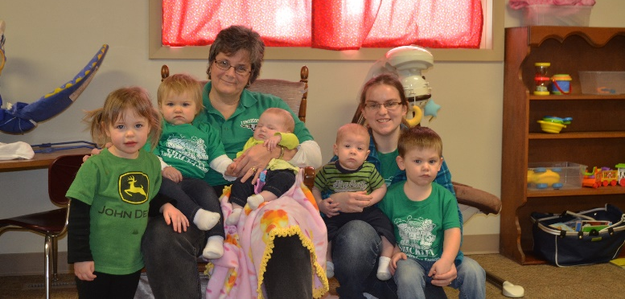

Pictured below are faculty and students who dressed in green to show their support for the “Go Green” project.

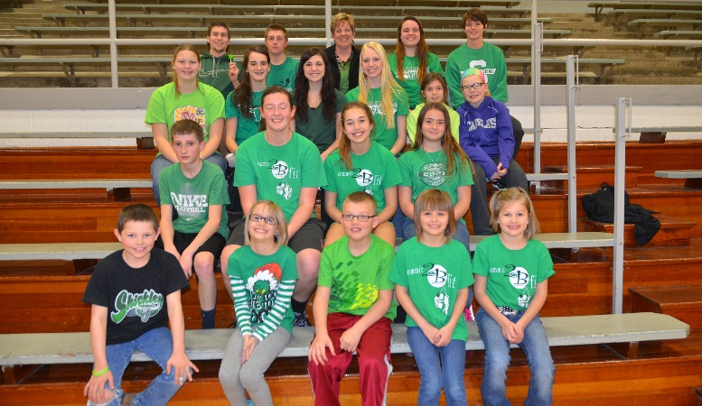

FFA Members Compete at District Level

FFA members completed proficiency applications based on their Supervised Agriculture Experience (SAE) and competed at the district level in February. These members showed growth in their SAE program and explained on the apllication how they continue to develop new skills. They also had to report income and expenses to show they can keep accurate records of either their job (placement) or their own business (entrepreneurship). Members competed in several different areas, such as: Agricultural Services Placement, Diversified Livestock Production Entrpreneurship, and Diversified Agriculture Production Placement. In the Agriculture Service Placement area Courtney Kamler, John Alfs, and Chris Lichti all received silvers. In Diversified Livestock Production Entrpreneurship Carley Swartzendruber received a bronze. In Diversified Agriculture Production Placement Blake Stengel received a gold and Kale Kleinschmidt received a bronze. Congratulations to these members on a job well done.

Pictured below are: Carley Swartzendruber, Kale Kleinschmmidt, Chris Lichti, John alfs, Courtney Kamler, and Blake Stengel.

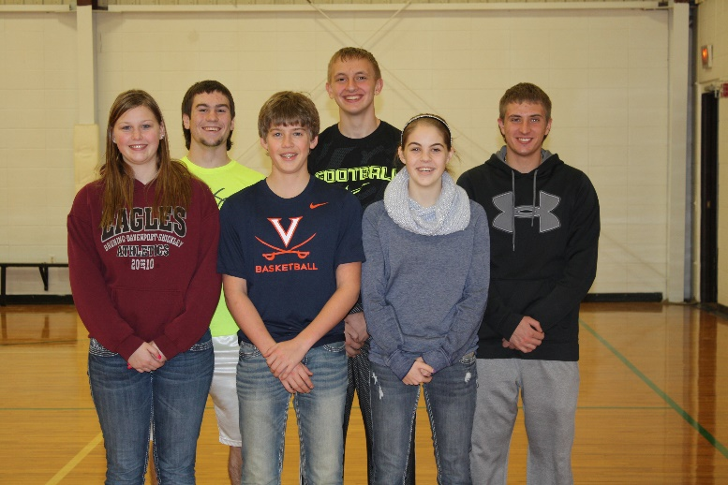

Letter from Mr. Ippensen, Principal

“Success is a process, a quality of mind and way of being, an outgoing affirmation of life.” – Alex Noble

If success is a process, then as we work at Shickley Public Schools to prepare students for success, what we are really doing is developing in them the skills, tools, and understandings – the knowledge and abilities – to take the next steps in their lives. This is a fair definition of education when you consider it. We send our children, our most precious resource, to school not solely to learn the information from their classes, but to learn to think. We send our children to school so they are able to meet the unknown, the unexpected, and the unforeseen. Then, rather than turn and run, or cower in fear, we have taught our students to respond to this new situation with the knowledge that they can not only survive said situation, but overcome it and thrive in spite of it. We don’t prepare our students for success by teaching them just enough to get by, we prepare them for success by helping them to develop the skills, tools, and understandings – the knowledge and abilities – they may need at each step of their lives, whether that step is 3rd grade, 12th grade, college, or career.

As always, if you have any questions or comments regading the work we are doing at Shickley Public School, or if you would like to share in the process of preparing our students for success, plese don’t hesitate to stop in and talk, or give us a call.

Derek Ippensen
PK-12 Principal
Shickley Public School
dippensen@longhornpower.org

