Hoofprint
Shickley Public School

…preparing students
for success…

December 2014

Monthly Newsletter

Notes from Mr. Jorgenson
It seems like we just started school a few weeks ago. As we are in the middle of the holiday season, it is important to reflect on what matters to you personally. A tradition of getting together as family and friends is a popular activity during this time of year. These events help us remember what matters most and helps to keep us focused. Do you ever think why it takes the holidays for us to remember to be thankful or to appreciate spending time with family and friends? The answer is simple. With our ever increasing busy lives, it is easy to veer off track. We tend to put other things in front of us that either happen unexpectedly or we allow events in our lives to control us. At school, it is my vision to always do what is in the best interest for students. I can easily lose focus because of distractions that occur throughout the year. However, I try to make my decisions based on what is best for the kids. As we proceed with the remainder of the year I will continue to follow this type of decision making and to prepare all of our students for success. As the holidays pass on, remember to be thankful throughout the year and to appreciate spending time with family and friends. I know I will.
Merry Christmas to you and yours,
Bryce Jorgenson
Superintendent
bjorgenson@longhornpower.org

Quarter One Honor Roll
All A Honor Roll
Seniors: Nathan Hendrickson, Megan Swartzendruber, and Kristen Troyer
Juniors: Catherine Mick and Tristen Mosier
Sophomores: Courtney Kamler
Freshmen: Megan Grote and Nicole Swartzendruber
Eighth Grade: Jackson Grote and Jadyn Kleinschmidt
Seventh Grade: Regan Alfs, Alyssa Nolt, and Joshua Swartzendruber

A Average Honor Roll

Seniors: Rio Mohrmann and Blake Stengel
Juniors: Madison Yantzie
Sophomores: Christian Lichti
Freshmen: Anthony Beavers, Lexi Kadel, Thomas Mick, Kellen Reinsch, and Jacob Swartzendruber
Eighth Grade: Caleb Hendrickson, Isaac Kamler, and Josiah Kamler
Seventh Grade: Raegan Fiala, Zachary Mosier, Kaylee Noel, and Justin Stengel

A and B Honor Roll

Seniors: Crayton Mosier and Samantha Plock

It is not about what it is,
it’s about
what it can become.
--Dr. Seuss
Trick-or-Treating for a Cause
Miss Johnson’s third grade class at Shickley Public School has been learning about the importance of being a good citizen. The class brainstormed ideas on things that they could do to help people in Shickley and surrounding communities. The class decided to Trick-or-Treat for the Fillmore County Food Pantry. The third graders dressed up in their costumes, but instead of being on a candy hunt, they collected canned and boxed goods. Students said they had fun helping others. Hanna and Lauren stated, “We did a little thing that made a big difference.”
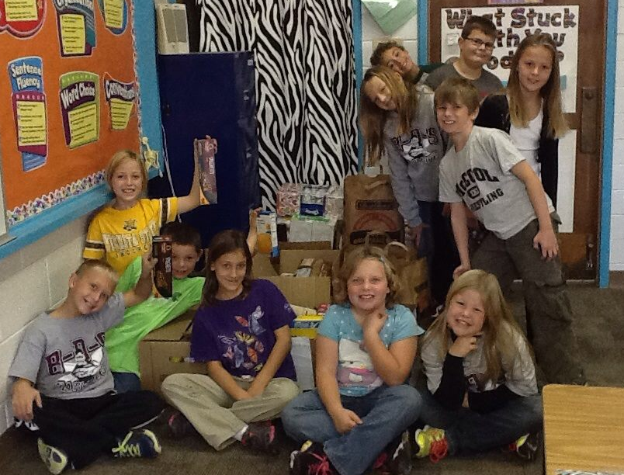
Pictured is the third grade class with all the goods they collected for the Fillmore County Food Pantry.

Doane Honor Festival
Five Shickley band students were chosen to attend the Doane Honor Festival held on Saturday, November 1st. The students attending the festival were divided up among three bands. Tristen Mosier played with the Tiger band. Carley Swartzendruber, Bret Smith, Logan Rosenquist, and Catherine Mick performed with the Merrill band. Each of the three bands rehearsed during the day and then performed a concert.
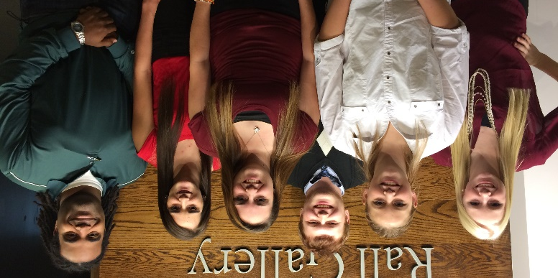
Thank you to our local businesses

The Shickley Daycare and Elementary students would like to say thank you to all of the businesses in Shickley who graciously handed out candy on Halloween. The seventy-five children really enjoyed walking to the local businesses for their trick-or-treating parade. It was definitely the highlight of their Halloween. Thank you!

Pictured is the first grade class in their costumes with their teacher Mrs. Nelson.

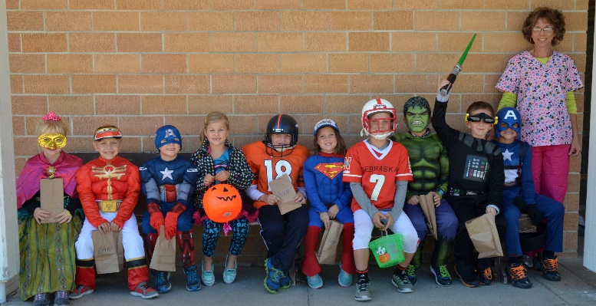

Physical Science Class Makes Ice Cream
The freshmen Physical Science class recently made ice cream. When they made the ice cream they first put their bag of milk and vanilla into a bigger bag of ice and salt. Once the bags were shut they shook the big bag for a minute and then checked the temperature of the milk bag. They continued to do this until the milk became thick like ice cream. When they shook the bag, heat from the milk transferred to the ice causing the ice to melt and the milk to become colder and start to freeze and get thicker. Heat moves from a warmer area to a cooler area which is why the heat left the milk to go to the ice which was cooler. This heat transfer is what created their ice cream.
Pictured are some of the students making ice cream.
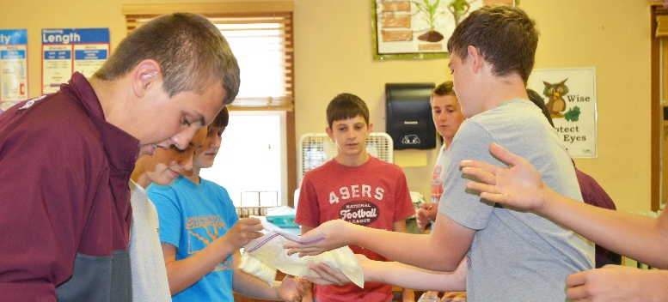

FFA Attends National Convention
National FFA Convention took place October 29th through November 1st in Louisville, Kentucky. Shickley FFA members that attended convention this year and had a great experience were Caleb Hendrickson, Anthony Beavers, Thomas Mick, John Alfs, Chris Lichti, Isaac Kamler, and Josiah Kamler. These members attended sessions, leadership workshops, and a career exposition. They had a chance to see all the different things FFA has to offer and network with other FFA members across the state. These members also went on a tour of the Jonabell horse farm in Lexington, Kentucky. They learned about the thoroughbred industry and had a chance to see the industry up close. John Alfs competed for Shickley FFA in the National AgriScience Fair at convention. He was interviewed by judges about his project and received a Silver in the Social Systems category. Chris Lichti was a member of the 2014 National FFA Choir and performed with 80 other members at various sessions, luncheons, and events. “It was an awesome experience and I got to meet kids from across the nation who enjoy music as much as I do,” said Lichti.

Thank You, Shickley Parents Association

Shickley Public School would like to thank the Shickley Parents Association (SPA) for donating money to help purchase two water fountains for the school. The new water fountains are equipped with bottle fillers that also filter the water. Thank you SPA for supporting our school.

Pictured is the kindergarten class by one of the new water fountains.

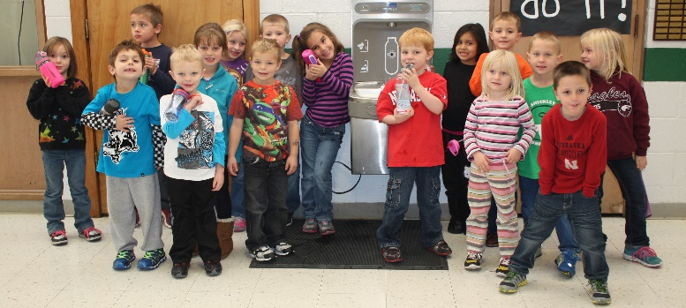

Thank You, Fillmore County Hospital

Shickley Public School would like to thank the Fillmore County Hospital for supporting the community of Shickley and the BDS athletic programs. To show their support the hospital donated BDS t-shirts.

Staff members are shown wearing some of the shirts donated by the hospital.

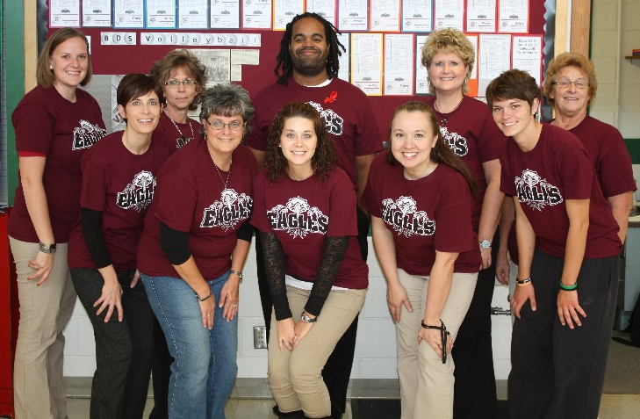

Lunchroom News

There have been a lot of changes over the past few years for the school lunch program. Change is sometimes difficult but we have found that change can also be good. To make healthier kids we need to make a few changes in what goes in them. One change we have made is the addition of more fresh fruits and vegetables. Along with more choices comes the responsibility to “take what you want but eat what you take.” This helps the school continue to provide these fresh choices. We will remind the children to be mindful of what they put on their trays, staying within the guidelines given to us. Kindergarten through sixth grade students need three fourths cup of fruits and/or vegetables daily. Junior and senior high students need one cup of fruits and/or vegetables daily. The lunchroom staff really appreciates the cooperation of the students as we all learn together how to eat healthier meals.

Fourth Grade News

The Shickley fourth grade class tried their hand in creating Native American tipis and earth lodges similar to those of the Plains Indian tribes. Each student worked hard and experienced the difficulties of building a home from materials they had to find themselves. This was a learning experience as they had to find the best possible materials to complete their models at the end of the unit on Native American life on the Plains.

Pictured are some of the tipis the students made.

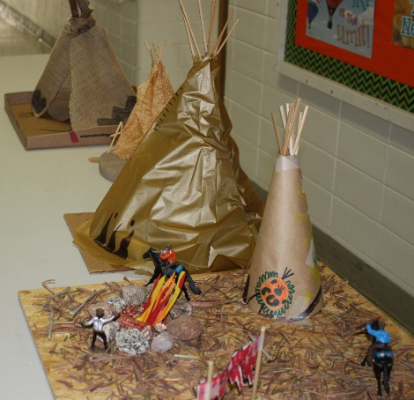

History News

“If you want to understand today, you have to search yesterday.” –Pearl Buck

This is so true about history and something that Mr. Shipley tries to get our students at Shickley to understand in great context. The seventh grade American Civics class is getting educated on the Constitution. The eighth grade Early American History class has begun to learn about the American Revolution. The tenth grade World History class is finding out great things about the Greek culture and civilization. In American History, the junior class is learning about the Progressive Movement and Women’s Rights. The senior American Government students are immersing themselves in the knowledge of our Congress. As you can see, the seventh-twelth grade students are busy learning about a wide variety of topics in the history classes we offer.

Pictured are the seniors researching information about our Congress.
Second Grade News

November was a very busy month for the second graders. In reading, they finished their unit 2 stories and learned various strategies to help them comprehend. Some of these were character, setting, plot, cause and effect, main idea and details, and compare and contrast. They also learned a thinking map skill which was newly adopted by the school. They used this when they were comparing and contrasting. In math, the students learned many concepts along with practicing addition facts. They truly enjoy being tested on their “Fast French Fry Facts!” When they pass a set of facts, Mrs. Mosier treats them to French fries. In writing, the children wrote Thankful Thanksgiving stories. They enjoyed putting together a turkey and cornucopia to help them brainstorm some ideas. December will be an exciting month because they will be learning the format of a letter and then writing letters to Santa! The students will also learn how to publish a book and will be writing one to send to a real publisher the end of the month. Let us know if you would like to buy our book.

Pictured is the second grade class and Mrs. Mosier with their French fries.

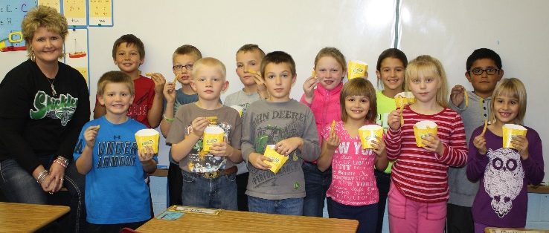

Student Council celebrates Red Ribbon Week

During the last week of October, Red Ribbon Week was observed at Shickley Public School. Red Ribbon week was created in memory of Enrique “KiKi” Camarena, a DEA officer sent into Mexico to halt the selling of drugs into the U.S. in the mid-1980’s. Officer Camarena knew the importance of stopping the selling and consumption of harmful drugs. After his death many friends created a week to reinforce the importance of not using illegal and harmful drugs. Throughout the week, Shickley’s Student Council put together small tokens to give to all PK-12 students as a reminder to stay away from harmful drugs and illegal substances.
Two Business Classes Compete in Online Fall Finance Challenge

The Shickley Business Economics and Accounting class and the Exploration of Business and Entrepreneurship class competed in the online Fall Finance Challenge. The students completed an online 30-question, rapid-fire exam consisting of categories on Income and Money Management, Spending and Credit, and Saving and Investing. The Business Economics and Accounting `Horns team consisting of Nathan Hendrickson, Ben Row, and Blake Stengel finished 29th out of 365 high school teams. The Exploration of Business and Entrepreneurship Green group consisting of Jackson Grote, Caitlin Mosier, Terry McBride, and Carolyn Lang finished 13th out of 29 middle school teams. The Exploration of Business and Entrepreneurship `Horns group consisting of Jadyn Kleinschmidt, Caleb Hendrickson, Isaac Kamler, and Josiah Kamler finished first in the middle school division! Each team member received a $25 cash prize for winning first place.

Pictured below are the Exploration of Business and Entrepreneurship students with teacher Mrs. Yantzie.

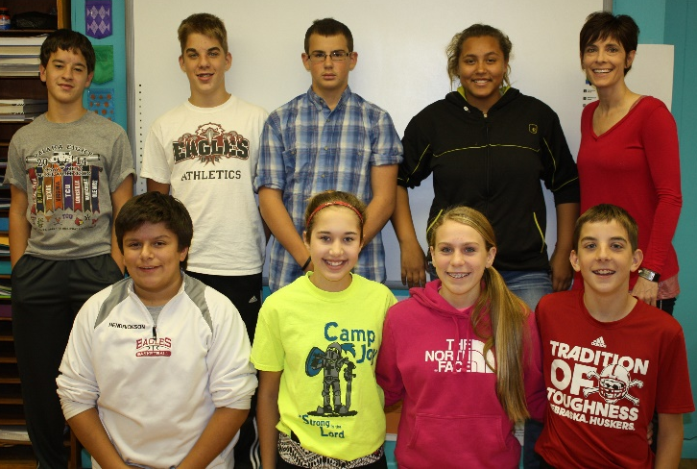

Biotechnology Team Wins First Place

Shickley FFA’s Biotechnology team traveled to Hasting on November 12th and competed in a Biotechnology contest. This contest was set up so individual members completed a tool identifcation quiz and then tested over basic biotechnology concepts. The team then completed a practicum where they had to use the biotechnolgy process to solve a problem. Members of the winning team consisted of Courtney Kamler, Chris Lichti, Crayton Mosier, and Ben Row. With this win the team qualified for the state contest in April.

Volleyball 2014

The 2014 volleyball season came to an end in the sub-district finals in Geneva in a hard fought 25-19, 24-26. 25-16, 19-25, 7-15 loss to the state-rated Friend Bulldogs. The team started the season off by playing numerous state-rated teams, as well as teams that made it to the state tournament. The strong competition kept the Lady Eagles from starting off on the winning side as they fell to a record of 6-9. With four new starters and a returning starter changing positions, the Eagles refused to quit and showed great improvement as the season progressed. The Lady Eagles finished the remainder of the season to finish on a 10-3 run, ending the season with a 16-12 record. Their regular season conference record stood at 6-4, good enough for a fifth place finish in the always rugged CRC competition. In the final regular season match the team showed their grit and improvement by defeating Lawrence/Nelson a state tournament qualifier. The coaches would like to thank all the girls for their hard work and dedication throughout the season.

Fine Arts Night

Fine Arts Night for Shickley Public School was held on Monday, November 10th. Community members were able to view a variety of quality artwork from students K-12 in the foyer to start the evening. The high school One Act Play, “Sherlock Holmes in Wonderland” provided outstanding entertainment for the audience. During intermission, an ice cream social was hosted by the Shickley Band Boosters. Afterwards, the high school marching band performed a court show on the gym floor. Fine Arts night was an opportunity to share the art, theater, and music talent of Shickey students with the community members. The night was led by art teacher Rebecca Jorgenson, drama coach Jennifer Ippensen, and band instructor Joshua Harris.

Pictured is some of the art work dislayed at Fine Arts Night.

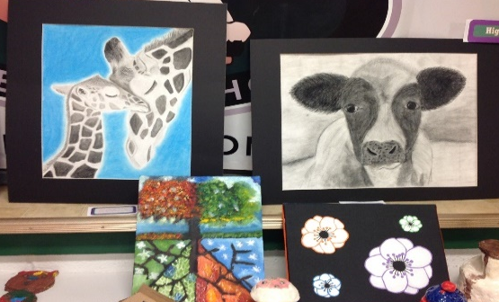

Eighth Grade English News

The Shickley eighth grade students recently interviewed individuals who have served in the United States military. The students began the project by researching both the branch of the military and any war or conflict their person was a member of. From there, the students created open-ended questions that they would later use to interview the veteran. Finally, the students wrote a summary about their interviewee’s military experience. The students took the information from their research and interview to create a speech that was presented in front of their classmates and the individuals they interviewed. Many of the students chose family members to interview for this project, which gave them an opportunity to learn more about their loved one’s personal experiences. The project allowed the students to further understand and appreciate the sacrifices all military personnel make to keep our country safe and free.

Some of the class members are pictured working on their visual aides for their speeches.

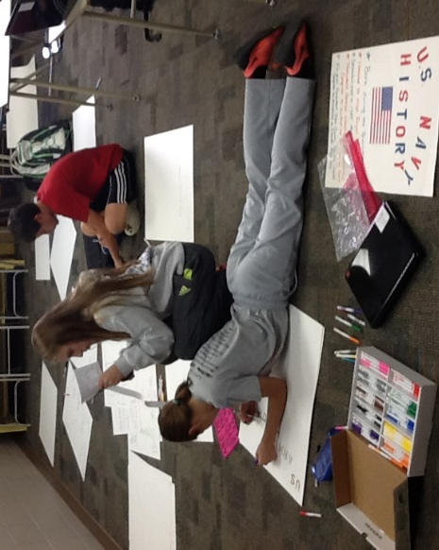

Jadyn Kleinschmidt is pictured with grandpa Richard Kleinschmidt whom she interviewed for the class.

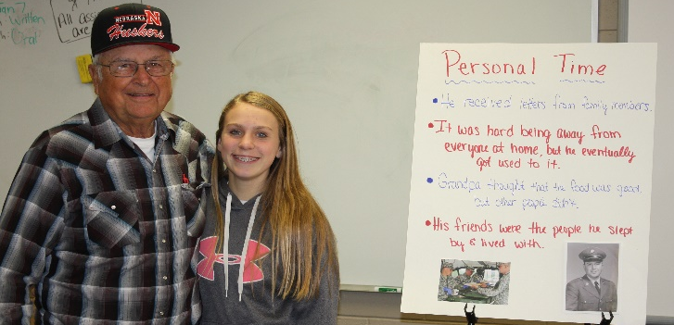

Veteran’s Day Program

On Tuesday, November 11th our school held a Veteran’s Day program. It was a program held to honor all the service men and women who served in all the branches of the military. Our school worked with our local Legion Post 164 to make this program special and meaningful. The kindergarten class led everyone in reciting the Pledge of Allegiance. The junior and senior high bands performed a number of songs. The junior high chorus and the senior high chorus both sang. Our school also honored two of our teachers who have served in the military. Thank you service men and women for serving our country.

Pictured are Scott Shipley and Joshua Harris our current teachers who have served in the military.

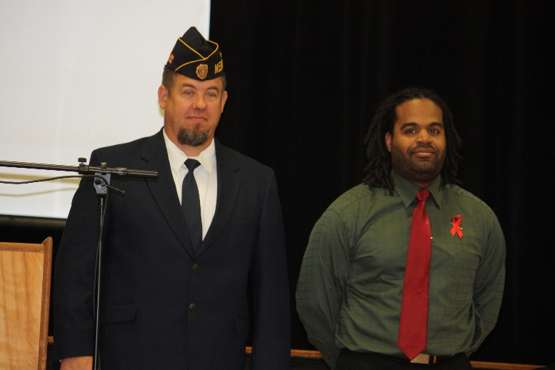

FFA Attends District Livestock Judging

On Wednesday, November 12th Shickley FFA members headed to Hastings to compete in the District Livestock Judging Contest. Livestock judgers had to place various livestock classes and also give oral reasons justifying their placings. Competing in the Senior Division were Samantha Plock, Blake Stengel, Nathan Hendrickson, Rio Mohrmann, and Megan Swartzendruber. The junior members were John Alfs (4th overall), Nicole Swartzendruber, Anthony Beavers, Holden Stengel, Lexi Kadel, Carley Swartzendruber, Kale Kleinschmidt, and Carley Elznic. The team of John Alfs, Nicole Swartzendruber, Anthony Beavers, and Holden Stengel narrowly missed qualifying for the state contest and placed fifth in the junior division. Competing in the Middle School Division were Isaac Kamler (3rd overall), Caleb Hendrickson, and Josiah Kamler.

A Little Bragging About Our Academic Successes

There is definitely a buzz in the air as I sit down to write this article, for today is the day our boys will compete in the state championship football game. The successes our students achieve on the playing field or in the gymnasium usually don’t go unnoticed, but unfortunately their successes in the classroom are not celebrated enough. Great things that are definitely worth celebrating have been happening in Shickley Public Schools on the academic fronts.

Academic achievement is measured by various methods, all involving student testing (NeSA, STARS, MAPS, Act, etc). There is much debate in education circles about the value of student testing as a means to gauge academic development. Suffice it to say, by any measure Shickley Students have been doing very well. I invite everyone to visit with our Administrators about our results.

“Academic Rigor” is the term used to describe the aggressiveness of a school curriculum at pushing students for academic development. Academic Rigor should be one of the top priorities of a school’s administrative team, and it is very important to me personally as a school board member and parent. Many school districts are consumed with issues that prevent them from being able to address academic rigor. We are very blessed at Shickley Public School to have the opportunity to focus on academic rigor continually. Our greatest asset for doing this is our dedicated, experienced, self-invested staff. Without them none of our student achievement would be possible.

Several years ago the School Board and Administrative Team engaged in long-term planning sessions for the school and made Academic Improvement one of our primary goals. Our Administrative Team and Teaching Staff took this goal and, through the School Improvement Planning process, made it a reality over the last few years.

Here are some concrete examples of steps taken to make the goal of Academic Improvement a reality:
- Invested in a pre-school to give children a head start on learning.
- Implemented changes in professional development for Teaching Staff and early-out Fridays to provide time for it.
- Implementation of new our Math and Reading curriculum from the grade school through high school.
- Invested in 1:1 computers in the junior high and high school and added iPads in the grade school.
- Added Accelerated Reader (AR) reading requirements through the high school years.
- Invested in facility improvements which directly impact the learning environment (e.g. science room).
- Aggressively re-vamped High School class schedules to allow students more options.
- Added to the number of dual-credit classes being offered to high school students.
You have probably heard the quote, “Success is not a destination but a journey.” For a school, that is definitely true because we must always be striving to improve. The Shickley School Board will soon be engaging in a long-term planning session to look forward and plan for the future. At the present moment I would like to again congratulate our Administrators and Staff for the great changes they have made to our school’s academic rigor. Job well done!

John Mick
School Board Member
Shickley Artwork Displayed at Nebraska Association of School Boards Convention

The Nebraska Association of School Boards (NASB) Convention was held November 19th-21st in LaVista. At this convention the Nebraska Art Teachers Association (NATA) held an art exhibit featuring artwork from students across the state of Nebraska. Art teacher, Mrs. Jorgenson, had two students’ artwork displayed during this year’s convention. Megan Swartzendruber and Madison Yantzie both had artwork on display there.
Ee’s

Pictured are Madison Yantzie’s charcoal drawing of a tiger and Megan Swartzendruber’s oil painting of a flower.

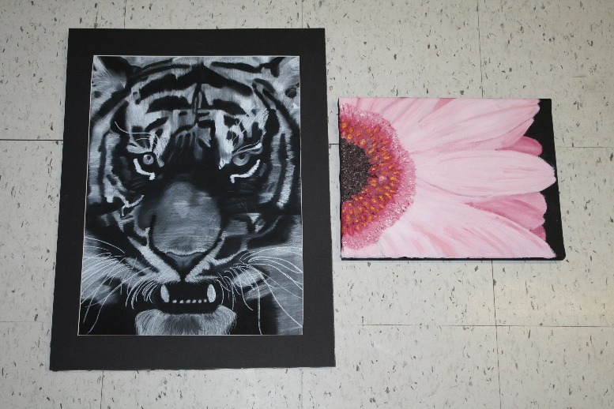

Letter from Mr. Ippensen, Principal

As we enter the holiday season, it is important to remember those who have made the work we do here at school possible. John F. Kennedy said, “We must find time to stop and thank the people who make a difference in our lives.”

And so, instead of discussing how we have gone about making changes in order to prepare our students for success, I would like to take time to thank the people who have made these changes possible. In my four years here, we have made numerous changes, and without the support of parents, the Board of Education, and the community, the progress we’ve made thus far would not have been possible. It is also through the teachers’ willingness to incorporate new curriculum in their classrooms and adopt new instructional strategies that we have made strides toward helping prepare our students for success. Their willingness to listen to someone new and follow the ideas and direction being presented has made change possible. Finally, our students need to be commended for their good attitudes throughout this process of affecting change. Without their willingness to try new things, deepen their understandings, and develop their skills, our efforts would not be successful.

We often say “Shickley is just a different place,” and it’s true. It’s true because of all the people involved in our educational process. Without everyone working together, these changes could not happen, and the school could not be what it is today, nor what it can be tomorrow. As always, if you have any questions or comments regarding the work we are doing at Shickley Public School, or if you would like to share in the process of preparing our students for success, please don’t hesitate to stop in and talk, or give us a call.

Derek Ippensen
PK-12 Principal

Football 2014

It was a great season for our BDS football team. During the season we completed the regular season with a record of 7-1 and beat 4 ranked teams. We then started our post season. We beat Omaha Christain Academy, Bloomfield, Heartland, and GACC. We traveled to Memorial Stadium and came home as D-1 State Runner-Ups. We ended our season with an 11-2 record. It was a memorable season for the team. The hard work, dedication, and unity the team displayed was great. The team and coaching staff would like to thank everyone who supported us and cheered us on this season.

